
Viewed by:
Guy Scruignec
Tel.: +33 (0)2 99 27 92 92
E-mail: guy.scruignec@iwedia.com

Written by:
Arnaud Viala
Tel.: +33 (0)2 99 27 92 92
E-mail: arnaud.viala@iwedia.com
IWEDIA

TDAL_TS Technical Specifications

V1.1

Approved by:
Thierry GARNIER
Tel.: +33 (0)2 99 27 92 92
E-mail: thierry.garnier@iwedia.com

SUMMARY
SUMMARY 2
1 Reference documents 5
2 Documentation History 6
3 Introduction 7
4 Module Overview and Architecture 8
4.1 Definitions, Acronyms and Abbreviations 8
4.2 General Description 9
4.2.1 TS Object 9
4.2.2 TS Route 10
4.2.3 TS Source 15
4.2.4 TS Sink 16
4.2.5 TS Route, Source, Sink interactions 17
4.2.5.1 Basic Zapper Platform (Non PVR): 17
4.2.5.2 One Watch&Record on one Tuner PVR Platform: 17
4.2.5.3 One Watch&Record and One Record on double Tuner PVR platform: 18
4.2.5.4 One Playback from HDD on PVR platform: 18
4.2.5.5 One Playback from HDD and Two Records on double tuner PVR platform: 19
4.3 Architecture 20
4.4 TDAL_TS API Description 21
4.4.1 Generic Interface 21
4.4.2 TS Route Interface 21
4.4.3 TS Source Interface 21
4.4.4 TS Sink Interface 22
5 TDAL_TS API Specification 25
5.1 Type Specifications 25
5.1.1 Generic 25
5.1.2 TS Route 25
5.1.3 TS Source 25
5.1.4 TS Sink 26
5.2 TDAL_TS API Usage 27
5.2.1 TS Source demux producing scenario 27
5.2.2 TS Source memory producing scenario 28
5.2.3 TS Sink demux consuming scenario 29
5.2.4 TS Sink memory consuming scenario 30
5.2.5 TS Source Jump request scenario 31
5.3 TDAL_TS Macro/Define/Enum/Typedef/Structure Definitions 32
5.3.1 Define Definitions 32
5.3.1.1 kTDAL_TS_MASK_CLASS 32
5.3.1.2 kTDAL_TS_MASK_TYPE 32
5.3.1.3 kTDAL_TS_MASK_INSTANCE 32
5.3.1.4 kTDAL_TS_NO_OBJECT 32
5.3.1.5 mTDAL_TS_GetObjectId 32
5.3.1.6 mTDAL_TS_GetObjectClass 32
5.3.1.7 mTDAL_TS_GetObjectType 32
5.3.1.8 mTDAL_TS_GetObjectInstance 33
5.3.2 Enum Definitions 34
5.3.2.1 Object class 34
5.3.2.2 Object type 34
5.3.2.3 tTDAL_TSROUTE_Error 34
5.3.2.4 tTDAL_TSSOURCE_Error 35
5.3.2.5 tTDAL_TSSOURCE_Type 35
5.3.2.6 tTDAL_TSSINK_Error 35
5.3.2.7 tTDAL_TSSINK_Type 36
5.3.3 Typedef Definitions 36
5.3.3.1 tTDAL_TS_Object 36
5.3.3.2 tTDAL_TSSOURCE_Handle 36
5.3.3.3 tTDAL_TSSOURCE_Pid 36
5.3.3.4 tTDAL_TSSOURCE_ProducerCallbackFct 36
5.3.3.5 tTDAL_TSSOURCE_RequestJumpCallbackFct 37
5.3.3.6 tTDAL_TSSOURCE_TimestampingCallbackFct 37
5.3.3.7 tTDAL_TSSINK_Handle 37
5.3.3.8 tTDAL_TSSINK_ConsumerCallbackFct 37
5.3.4 Structure Definitions 38
5.3.4.1 tTDAL_TSROUTE_Capabilities 38
5.3.4.2 tTDAL_TSROUTE_Status 39
5.3.4.3 tTDAL_TSSOURCE_OpenParam 40
5.3.4.4 tTDAL_TSSOURCE_ConfigParam 41
5.3.4.5 tTDAL_TSSINK_OpenParam 42
5.3.4.6 tTDAL_TSSINK_StartParam 43
5.3.4.7 tTDAL_TSSINK_Status 44
5.4 TDAL_TS API Functions 45
5.4.1 TS Generic Interface API 45
5.4.1.1 TDAL_TS_APIRevisionGet(-) 45
5.4.1.2 TDAL_TS_PlatformRevisionGet(-) 45
5.4.2 TS Route Interface API 46
5.4.2.1 TDAL_TSROUTE_Init(-) 46
5.4.2.2 TDAL_TSROUTE_Term(-) 47
5.4.2.3 TDAL_TSROUTE_GetCapability(-) 48
5.4.2.4 TDAL_TSROUTE_Connect(-) 49
5.4.2.5 TDAL_TSROUTE_Disconnect(-) 50
5.4.2.6 TDAL_TSROUTE_GetStatus(-) 51
5.4.3 TS Source Interface API 52
5.4.3.1 TDAL_TSSOURCE_Init(-) 52
5.4.3.2 TDAL_TSSOURCE_Term(-) 53
5.4.3.3 TDAL_TSSOURCE_Open(-) 54
5.4.3.4 TDAL_TSSOURCE_Config(-) 55
5.4.3.5 TDAL_TSSOURCE_Close(-) 56
5.4.3.6 TDAL_TSSOURCE_AddPid(-) 57
5.4.3.7 TDAL_TSSOURCE_RemovePid(-) 58
5.4.3.8 TDAL_TSSOURCE_Start(-) 59
5.4.3.9 TDAL_TSSOURCE_Stop(-) 60
5.4.3.10 TDAL_TSSOURCE_SetTimestampingCallback(-) 61
5.4.3.11 TDAL_TSSOURCE_NotifyProduction(-) 62
5.4.3.12 TDAL_TSSOURCE_Pause(-) 63
5.4.3.13 TDAL_TSSOURCE_Resume(-) 64
5.4.4 TS Sink Interface API 65
5.4.4.1 TDAL_TSSINK_Init(-) 65
5.4.4.2 TDAL_TSSINK_Term(-) 66
5.4.4.3 TDAL_TSSINK_Open(-) 67
5.4.4.4 TDAL_TSSINK_Close(-) 68
5.4.4.5 TDAL_TSSINK_Start(-) 69
5.4.4.6 TDAL_TSSINK_StartFrom(-) 70
5.4.4.7 TDAL_TSSINK_Stop(-) 72
5.4.4.8 TDAL_TSSINK_SetTimePosition(-) 73
5.4.4.9 TDAL_TSSINK_GetPacketPosition(-) 74
5.4.4.10 TDAL_TSSINK_GetStatus(-) 75
5.4.4.11 TDAL_TSSINK_SetConsumerCallback(-) 76
5.4.4.12 TDAL_TSSINK_NotifyConsumption(-) 77
5.4.4.13 TDAL_TSSINK_SetTSSource(-) 78
6 TDAL_TS External DependEncies 79
6.1 tTDAL_TSSOURCE_ProducerCallbackFct 79
6.2 tTDAL_TSSOURCE_RequestJumpCallbackFct 81
6.3 tTDAL_TSSOURCE_TimestampingCallbackFct 82
6.4 tTDAL_TSSINK_ConsumerCallbackFct 83

Reference documents
The following documents were used to write this specification:

Document | Version | Title
[ETSI TR 101 154 ] | V1.7.1 | Digital Video Broadcasting (DVB);  Implementation guidelines for the use of Video and Audio Coding in Broadcasting Applications based on the MPEG-2 Transport Stream

Documentation History

History
Vers. | Date | Nature
0.1 | 02/05/2006 | ARV: Merge of 3 different “Specifications V0.1” documents ([TDAL_TSROUTE, TSSINK and TSSOURCE).
1.0 | 02/01/2008 | GS: Update after reviews.
1.1 | 17/04/2008 | ARV: Add a member ‘end_of_injection’ to structure tTDAL_TSSINK_Status.

Introduction
The purpose of this document is to specify the interface and to describe the internal design of the Thin Driver Adaptation Layer Transport Stream [TDAL_TS]. The aim of this module is to provide a complete interface between middlewares and the transport stream routing, producing and consuming stage low level driver of a set-top-box.

Module Overview and Architecture

Definitions, Acronyms and Abbreviations
PVR | : Personal Video Recorder
TS | : Transport Stream
HDD | : Hard Disk Driver
IP | : Internet Protocol
IEEE1394 | : FireWire input (Apple Inc.'s brand name)
PID | : Packet Identifier. A unique integer value used to associate elementary streams of a program in a single or multi-program TS
STB | : Set-Top-Box

General Description
The main job of the TDAL_TS is to manage transport stream stage of a set-top-box especially in a PVR context. In a non PVR context, only a minimal implementation of TDAL_TS is needed.
Some general descriptions need first to be done.
Due to hardware constraints and experience learned by the PVR team, it appeared that the driver interface to manage a complete PVR application (Live, Watch’n’record, Time shifting, Trick modes …), must be of type TS producer/TS consumer. The reader must understand that with such capabilities (double tuner, PVR, IP connection…), TS routing within a STB must identify who is the TS producer and who is the TS consumer.
The TDAL_TS driver is a set of three sub-modules:
- TDAL_TSROUTE interface gives all flexibility for a client application to manage connections between TS inputs (tuner front-end, software entry, …) and demuxes. Only, this part must be implemented in a non PVR context.
- TDAL_TSSOURCE interface gives all flexibility for a client application to provide a TS coming from any kind of source (demux, HDD, IP connection, …) and can handle each kind of sources constraints and specificities. Depending on the TS source (demultiplexer or others), TDAL_TSSOURCE works in two kinds of mode (demux or memory), this is discussed in the general description chapter 4.2.3 TS Source.
- TDAL_TSSINK interface gives all flexibility for a client application to make use of a TS and link it to a producer (previously defined and configured through TDAL_TSSOURCE API calls).This driver can handle different kind of destination (Live i.e. to the MPEG decoder or memory to be written on a HDD for instance). TDAL_TSSINK, like TDAL_TSSOURCE, defines two kinds of mode (demux or memory), this is discussed in the general description chapter 4.2.4 TS Sink.

TS Object
The concept of TDAL_TS object is used to allow TDAL_TS sub-modules to discuss together. A TDAL_TS object represents different types of hardware piece (tuner, demux, memory buffer, IEEE1394) instance. This instance is also classified as a source or destination.
Some assumptions are made by the client of TDAL_TS client:
- TDAL_TS supports only a mono audio/video decoding platform. This implies that only one source memory buffer object instance 0 is available.
- The destination demux object instance 0 is the demux which feeds the audio/video decoding hardware pieces.
- The destination demux object instance 1 to n are the demuxes which are used to TDAL_TSOURCE extraction sessions.

Thus, TDAL_TSSINK and TDAL_TSSOURCE can not be disassociated and must be used together.

TS Route
The job of TS Route sub-module is to connect and disconnect different TDAL_TS objects.
Different connexion scenarios are listed below.

Watch a live program in a non PVR context:
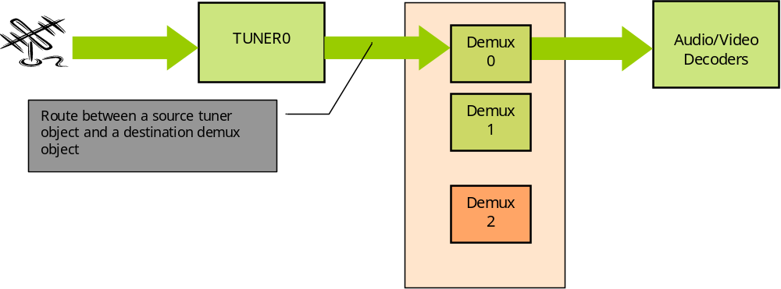
Watch a live program in a PVR context:
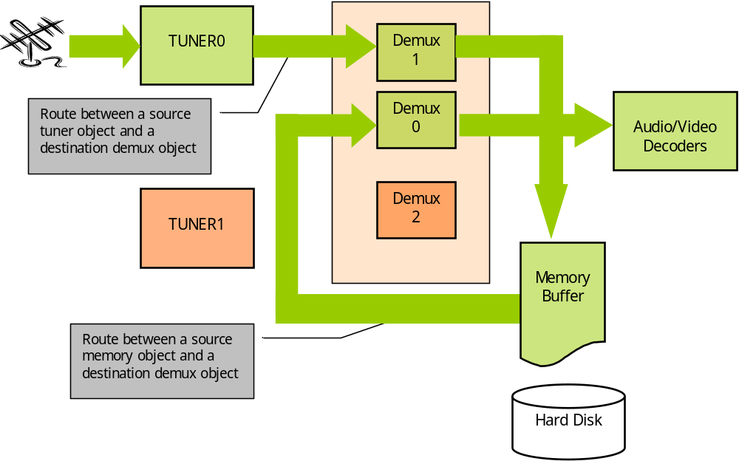
Watch a recorded program:
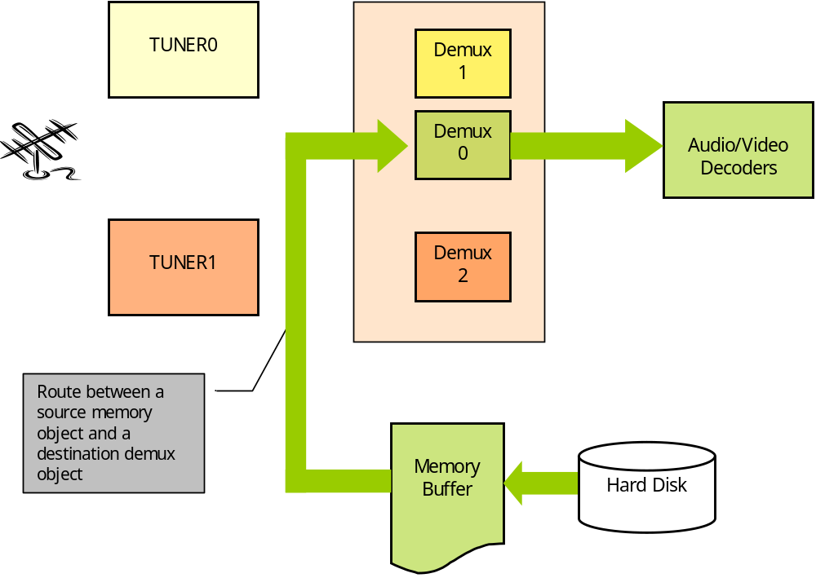

Record a program or pause a live program (time-shifting):
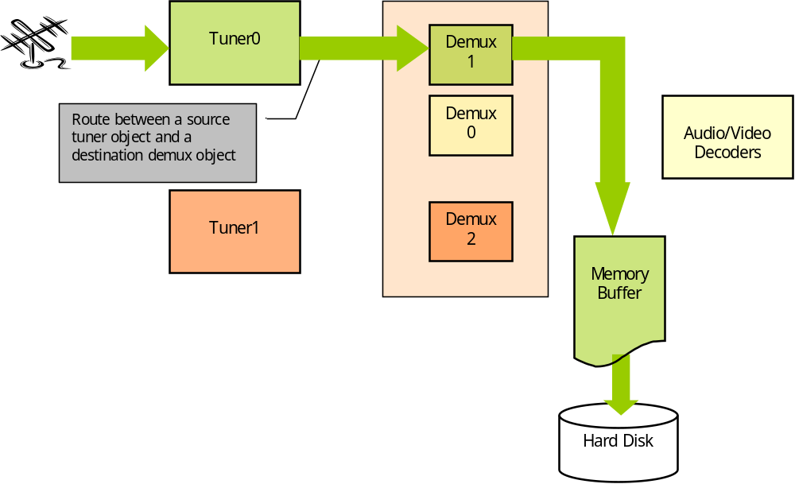
Watch and record a live program:
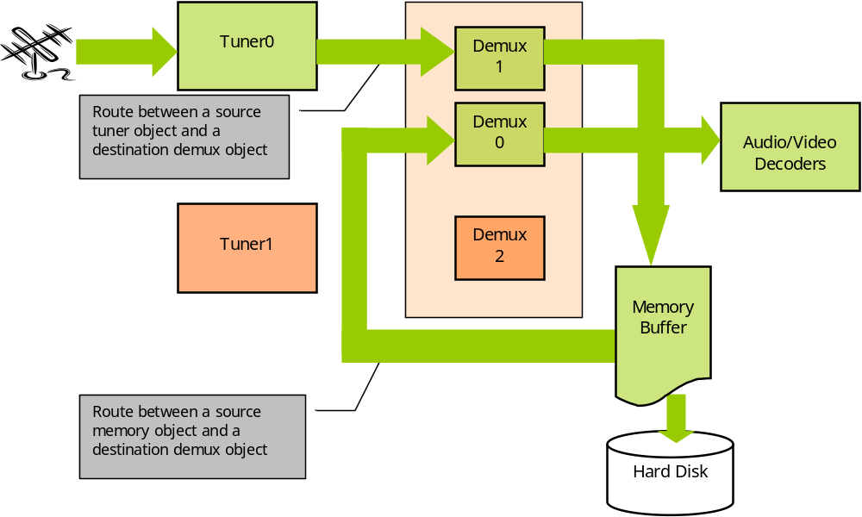
Watch a time-shifted program:
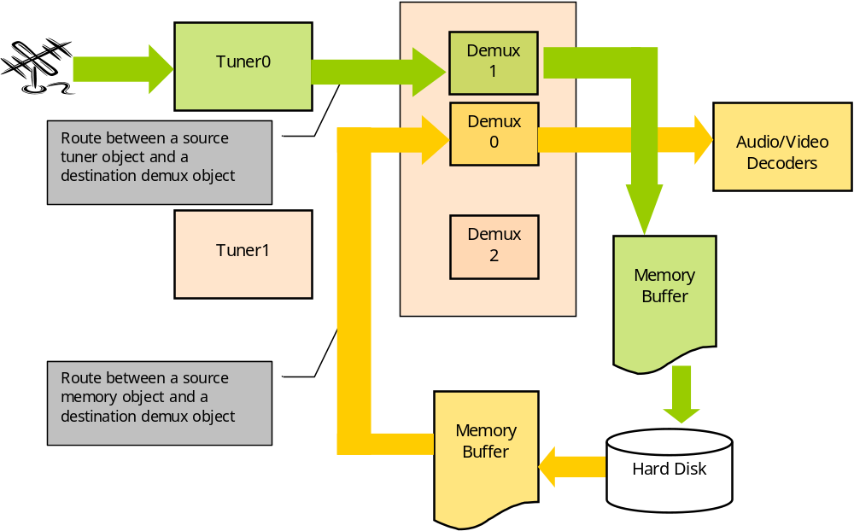
Watch and record a live program and record a second program:
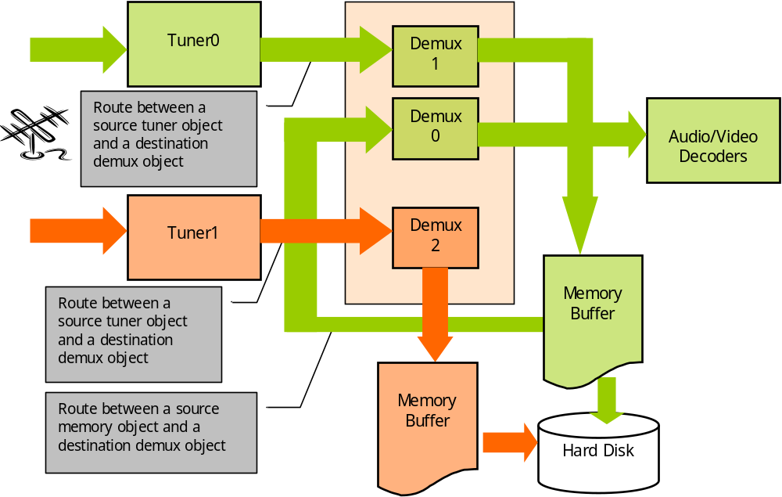
Record a program or pause a live program (time-shifting) and record a second program:
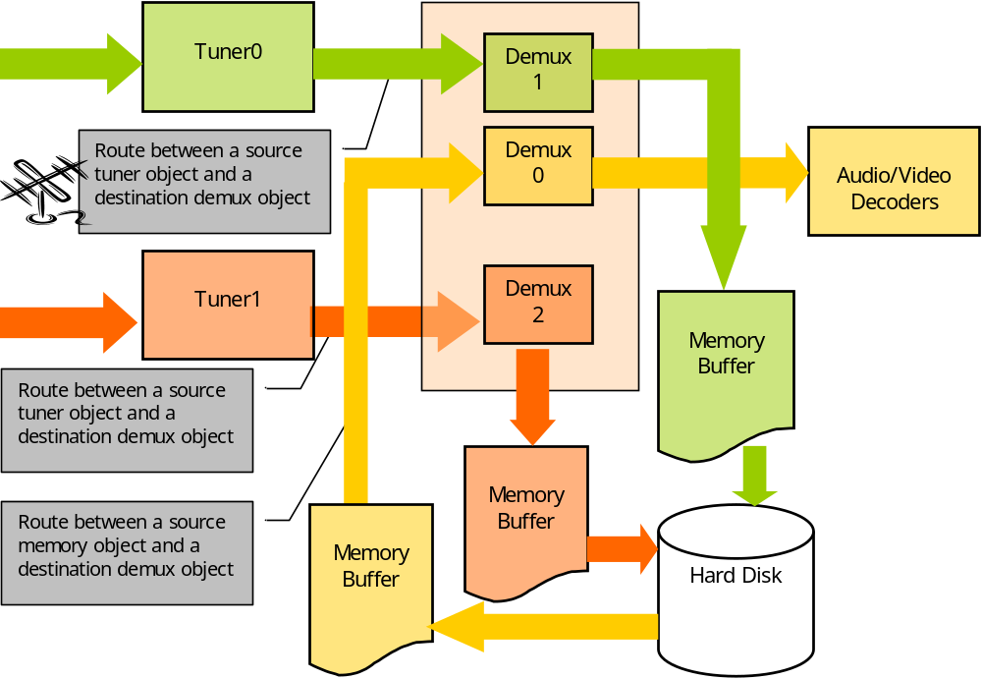

TS Source
Several TDAL_TSSOURCE sessions can be opened with different working modes.
TDAL_TSSOURCE defines two kinds of working mode:
- The demux working mode: this mode must be used when TS packets are coming from a demultiplexer. In this case, a subset of the interface is available. This is a simple interface as the client just has to specify the PIDs to be filtered to be later consumed by TDAL_TSSINK calls. TDAL_TSSOURCE handles every thing internally.
- The memory working mode: In this case an interaction between the client (producer) and TDAL_TSSOURCE is mandatory. The client must follow the Producing scenario as described in the related chapter. A subset of the interface is also available in this case.
To use TDAL_TSSOURCE, the client MUST have his own context to take part a producing scenario. This is important as tasks synchronisation is done through semaphores and could lead to a dead lock.
Note also that TDAL_TSSOURCE granularity in term of amount of data counting is in number of TS packets.
In memory mode, as the internal buffer of TDAL_TSSOURCE could be handled in a circular manner, two addresses and available free sizes are notified to the client as shown in the diagram below:
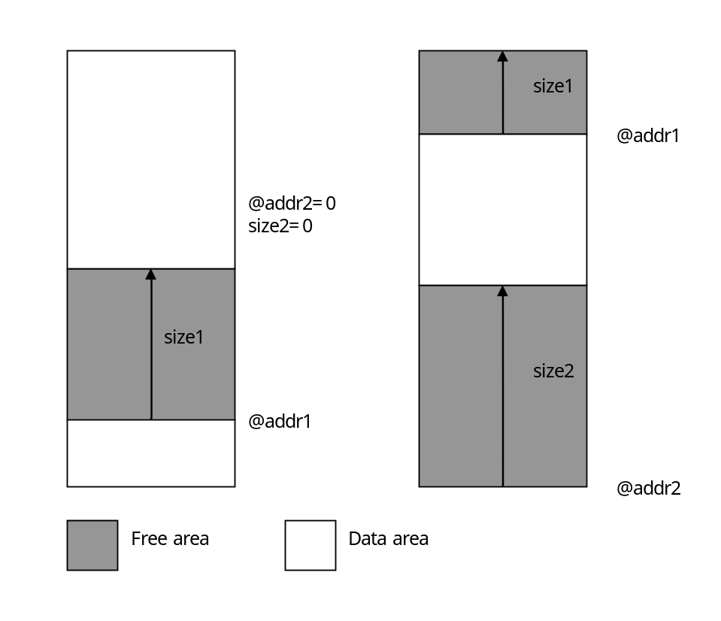

TS Sink
Several TDAL_TSSINK sessions can be opened with different working modes.
TDAL_TSSINK defines two kinds of working mode:
- The demux working mode: this mode must be used when TS packets are dedicated to a demultiplexer (to be played by an MPEG decoder for instance). In this case, a subset of the API is available. This is a simple interface as the client just has to specify the TS consumer and start the consuming. TDAL_TSSINK handles every thing internally.
- The memory working mode: In this case an interaction between the client (the consumer) and TDAL_TSSINK is mandatory. The client must follow the Consuming scenario as described in the related chapter. A subset of the interface is also available in this case.
To use TDAL_TSSINK, the client MUST have his own context to take part a consuming scenario. This is important as tasks synchronisation is done through semaphores and could lead to a system dead lock.
Note also that TDAL_TSSINK granularity in term of amount of data counting is in number of TS packets.
In memory mode, as the internal buffer of TDAL_TSSINK could be handled in a circular manner, two addresses and available data sizes are notified to the client as shown in the diagram below:
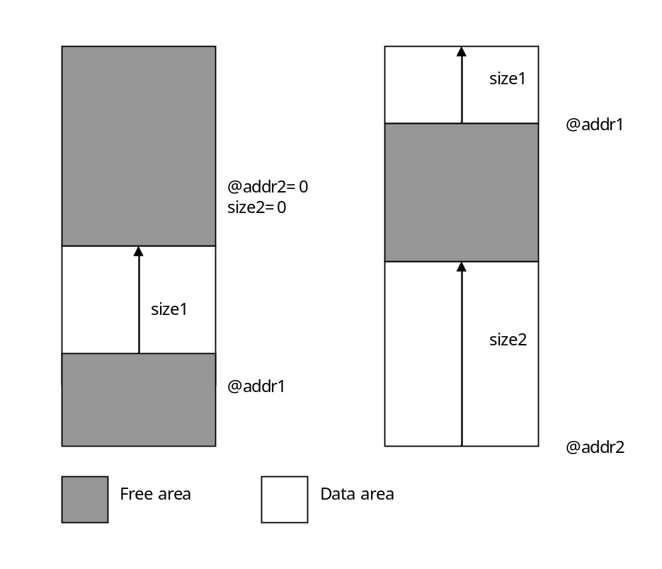

TS Route, Source, Sink interactions
The diagrams below describe the different interactions between TDAL_TS objects, TDAL_TSROUTE connections, TDAL_TSSOURCE sessions and TDAL_TSSINK sessions.

Basic Zapper Platform (Non PVR):
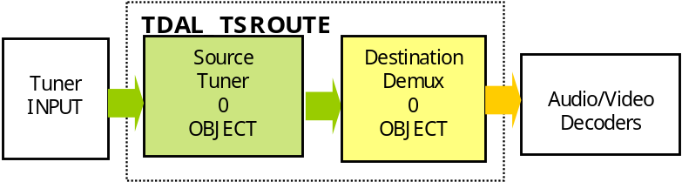

One Watch&Record on one Tuner PVR Platform:
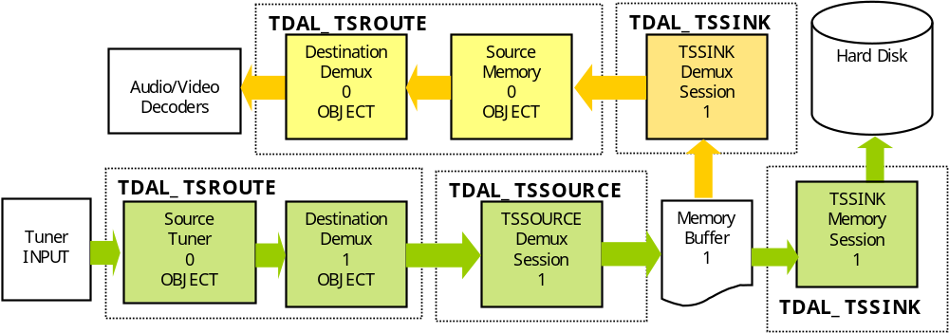

One Watch&Record and One Record on double Tuner PVR platform:
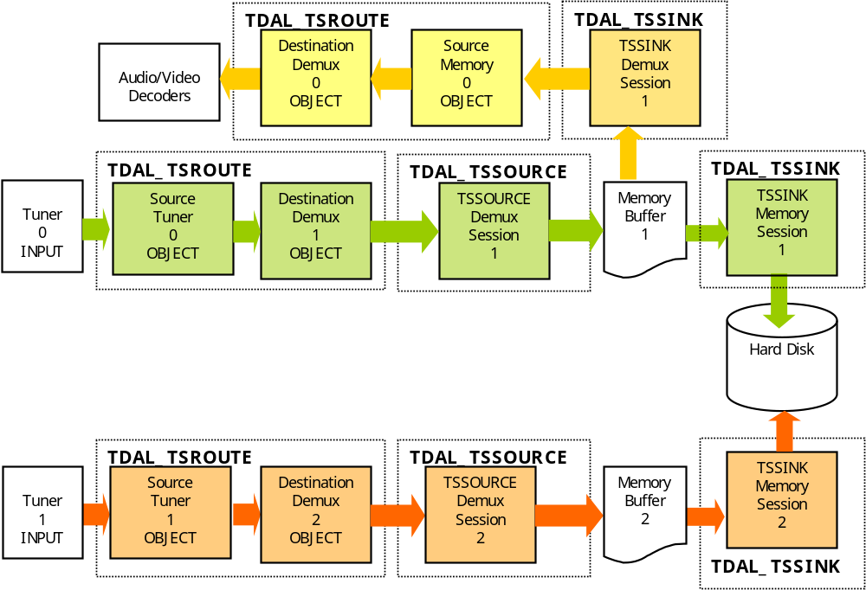

One Playback from HDD on PVR platform:
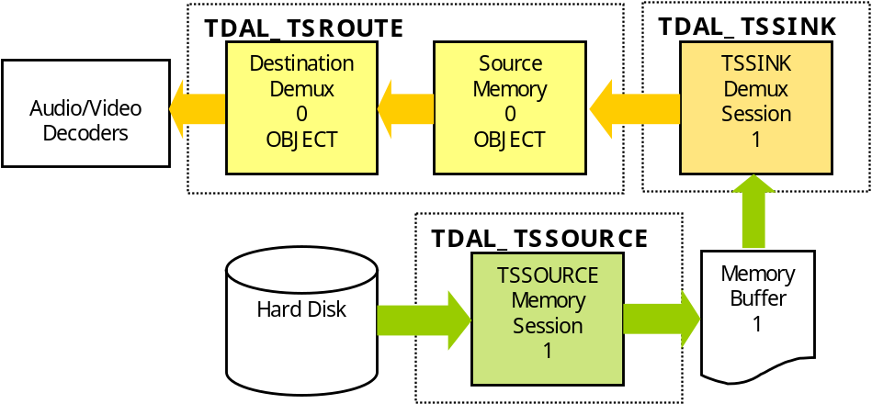

One Playback from HDD and Two Records on double tuner PVR platform:
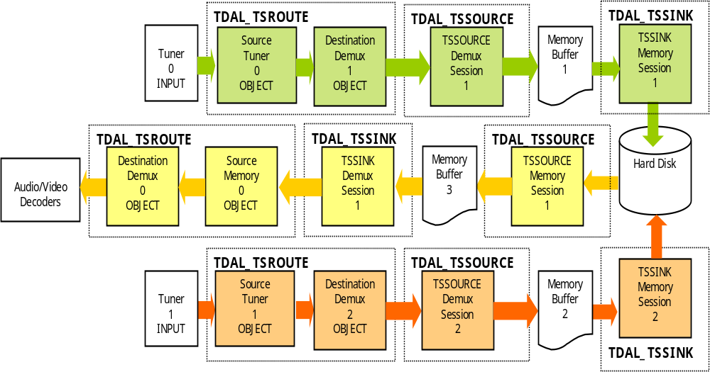

Architecture
The figure below shows the relation between the client module and the low level drivers:
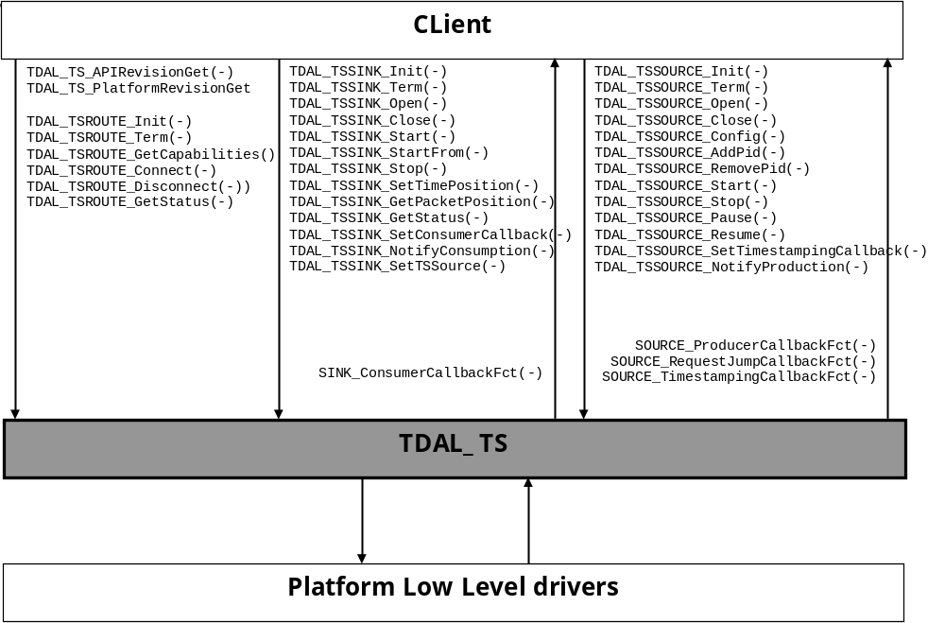

TDAL_TS API Description

Generic Interface
The generic interface allows clients to control the TDAL_FS module.
This interface is used with the following functions:
- TDAL_TS_APIRevisionGet(-) in order to retrieve the version of the TDAL_TS API.
- TDAL_TS_PlatformRevisionGet(-) in order to retrieve the version of the TDAL_TS platform implementation.

TS Route Interface
The TS Route interface allows clients to control the TDAL_TSROUTE module.
This interface is used with the following functions:
- TDAL_TSROUTE_Init(-) in order to initialize the TDAL_TSROUTE module.
- TDAL_TSROUTE_Term(-) in order to terminate the TDAL_TSROUTE module.
- TDAL_TSROUTE_GetCapabilities(-) in order to get the capabilities of the current implementation of TDAL_TSROUTE module.
- TDAL_TSROUTE_Connect(-) in order to connect a source object and a destination object.
- TDAL_TSROUTE_Disconnect(-) in order to disconnect a source object and a destination object.
- TDAL_TSROUTE_GetStatus(-) in order to get the status of an object (see tTDAL_TSROUTE_Status structure).

TS Source Interface
The TS Source interface allows clients to control the TDAL_TSSOURCE module.
This interface is used with the following functions:
- TDAL_TSSOURCE_Init(-) in order to initialize the TDAL_TSSOURCE module.
- TDAL_TSSOURCE_Term(-) in order to terminate the TDAL_TSSOURCE module.
- TDAL_TSSOURCE_Open(-) in order to open a TDAL_TSSOURCE session and defines the working mode.
- TDAL_TSSOURCE_Close(-) in order to close the TDAL_TSSOURCE session.
- TDAL_TSSOURCE_Config(-) in order to configure an extraction session.
- TDAL_TSSOURCE_AddPid(-) in order to add a PID to an extraction session.
- TDAL_TSSOURCE_RemovePid(-) in order to remove a PID from an extraction session.
- TDAL_TSSOURCE_Start(-) in order to start TS source.
- TDAL_TSSOURCE_Stop(-) in order to stop TS source.
- TDAL_TSSOURCE_SetTimestampingCallback(-) in order to set the time stamping consumer call-back.
- TDAL_TSSOURCE_NotifyProduction(-) in order to notify that buffer is processed and could be re-used.
- TDAL_TSSOURCE_Pause(-) in order to pause TS source
- TDAL_TSSOURCE_Resume(-) in order to resume TS source.

The table below lists the function available in different TDAL_TSSOURCE working modes:
Working modes | Functions
Both | TDAL_TSSOURCE_Init(-)  TDAL_TSSOURCE_Term(-)  TDAL_TSSOURCE_Open(-)  TDAL_TSSOURCE_Close()  TDAL_TSSOURCE_Start(-)  TDAL_TSSOURCE_Stop(-)  TDAL_TSSOURCE_Config(-)
Demux | TDAL_TSSOURCE_AddPid(-)  TDAL_TSSOURCE_RemovePid(-)  TDAL_TSSOURCE_SetTimestampingCallback(-)
Memory | TDAL_TSSOURCE_NotifyProduction(-)  TDAL_TSSOURCE_Pause(-)  TDAL_TSSOURCE_Resume(-)

TS Sink Interface
The TS Sink interface allows clients to control the TDAL_TSSINK module.
This interface is used with the following functions:
- TDAL_TSSINK_Init(-) in order to initialize the TDAL_TSSINK module.
- TDAL_TSSINK_Term(-) in order to terminate the TDAL_TSSINK module.
- TDAL_TSSINK_Open(-) in order to open a TDAL_TSSINK session and defines the working mode.
- TDAL_TSSINK_Close(-) in order to close the TDAL_TSSINK session.
- TDAL_TSSINK_Start(-) in order to start consuming a TS (any kind of working mode).
- TDAL_TSSINK_StartFrom(-) in order to start consuming a TS at the same position of a TDAL_TSSINK “predecessor” session (any kind of working mode).
- TDAL_TSSINK_Stop(-) in order to stop consuming a TS (any kind of working mode).
- TDAL_TSSINK_SetConsumerCallback(-) in order to allow the client to register a callback used to consume a TS (only available in memory working mode).
- TDAL_TSSINK_NotifyConsumption(-) in order to update TDAL_TSSINK with the exact number of TS packets produced and gives a wish of TS packet number that can be produced before being called back in the consuming scenario (please refer to the Scenario chapter).
- TDAL_TSSINK_SetTSSource(-) in order to set the TDAL_TSSOURCE session of the consumed TS.
- TDAL_TSSINK_GetStatus(-) in order to get status information about an injection.
- TDAL_TSSINK_SetTimePosition(-) in order to set time position in TS.
- TDAL_TSSINK_GetPacketPosition(-) in order to get packet position in TS.

The table below lists the function available in different TDAL_TSSINK working modes:
Working modes | Functions
Both | TDAL_TSSINK_Init(-)  TDAL_TSSINK_Term(-)  TDAL_TSSINK_Open(-)  TDAL_TSSINK_Close()  TDAL_TSSINK_Start(-)  TDAL_TSSINK_StartFrom(-)  TDAL_TSSINK_Stop(-)  TDAL_TSSINK_SetTSSource(-)
Demux | TDAL_TSSINK_GetStatus(-)  TDAL_TSSINK_SetTimePosition(-)  TDAL_TSSINK_GetPacketPosition(-)
Memory | TDAL_TSSINK_SetConsumerCallback(-)  TDAL_TSSINK_NotifyConsumption(-)

TDAL_TS API Specification

Type Specifications

Generic
The object identifier tTDAL_TS_Object is the way used by an application to access in a single way a specific TDAL_TS object.
Some macros are defined to get some information on an object:
- mTDAL_TS_GetObjectClass(object) to get the class (source or destination) of a TDAL_TS object.
- mTDAL_TS_GetObjectType(object) to get the type (tuner, demux, memory, IEEE1394) of a TDAL_TS object.
- mTDAL_TS_GetObjectInstance(object) to get the instance (0,…,n) of a TDAL_TS object.
- mTDAL_TS_GetObjectId(class, type , instance) to get the object from its class, type and instance.

TS Route
tTDAL_TSROUTE_Error is defined to identify an error of the TDAL_TSROUTE interface.
tTDAL_TSROUTE_Capabilities is defined to get the capabilities of the TDAL_TSROUTE current implementation.
tTDAL_TSROUTE_Status is defined to get the status of specific TDAL_TS object.

TS Source
tTDAL_TSSOURCE_Error is defined to identify an error of the TDAL_TSSOURCE interface.
The TDAL_TSSOURCE identifier tTDAL_TSSOURCE_Handle is the way used by an application to access in a single way a specific TDAL_TSSOURCE session.
tTDAL_TSSOURCE_Type defines the demux TS extraction or memory production type of a TDAL_TSSOURCE session.
tTDAL_TSSOURCE_Pid defines the pid value to extract.
tTDAL_TSSOURCE_ProducerCallbackFct defines the prototype of the callback function called during a memory production session when data can be produced.
tTDAL_TSSOURCE_RequestJumpCallbackFct defines the prototype of the callback function called during a memory production session when a jump in the source stream is needed.
tTDAL_TSSOURCE_TimestampingCallbackFct defines the prototype of the callback function called during a demux TS extraction session when a TS time stamping must be handled by client application.
tTDAL_TSSOURCE_OpenParam defines the open parameters of a TDAL_TSSOURCE session.
tTDAL_TSSOURCE_ConfigParam defines the configuration parameters of TDAL_TSSOURCE session.

TS Sink
tTDAL_TSSINK_Error is defined to identify an error of the TDAL_TSSINK interface.
The TDAL_TSSINK identifier tTDAL_TSSINK_Handle is the way used by an application to access in a single way a specific TDAL_TSSINK session.
tTDAL_TSSINK_Type defines the demux TS insertion (also called demux software TS input) or external memory consumer type of a TDAL_TSSINK session.
tTDAL_TSSINK_OpenParams defines the open parameters of a TDAL_TSSINK session.
tTDAL_TSSINK_ConsumerCallbackFct defines the prototype of the callback function called during a memory consumption session when data can be consumed.
tTDAL_TSSINK_StartParams defines the start parameters of a TDAL_TSSINK session.
tTDAL_TSSINK_Status defines the status information of demux TS insertion.

TDAL_TS API Usage

TS Source demux producing scenario
This schematic is an example of TDAL_TSSOURCE usage in a case of demux working mode.

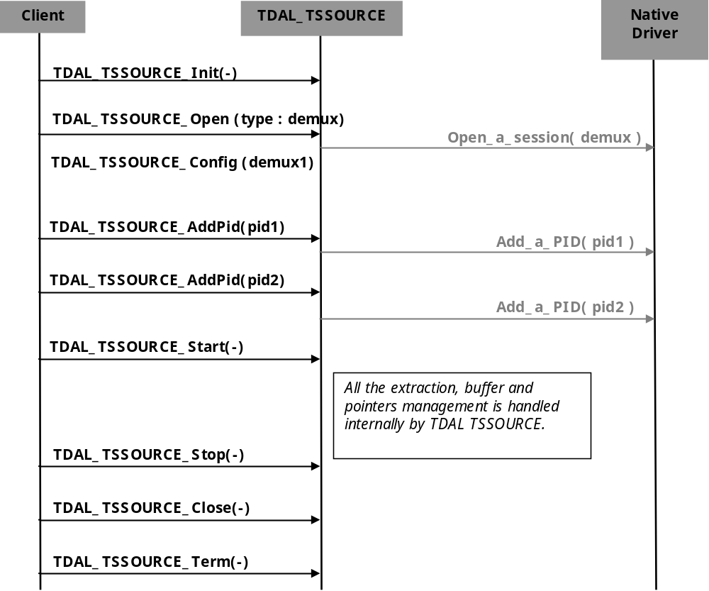

TS Source memory producing scenario
This schematic is an example of TDAL_TSSOURCE usage in a case of memory working mode.

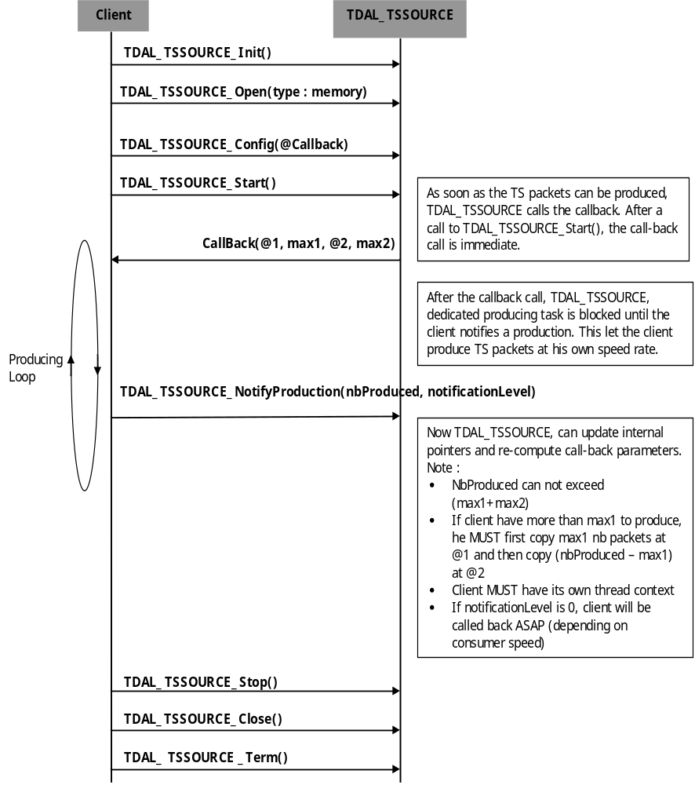

TS Sink demux consuming scenario
This schematic is an example of TDAL_TSSINK usage in a case of demux working mode.

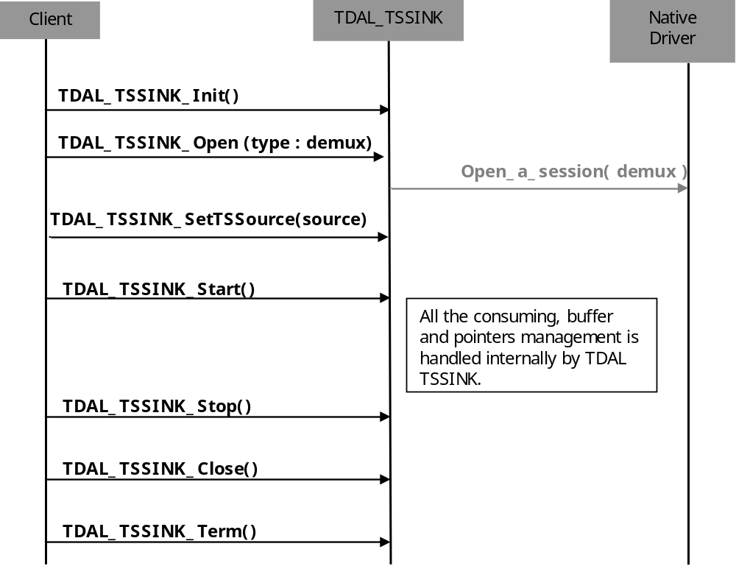

TS Sink memory consuming scenario
This schematic is an example of TDAL_TSSINK usage in a case of memory working mode.

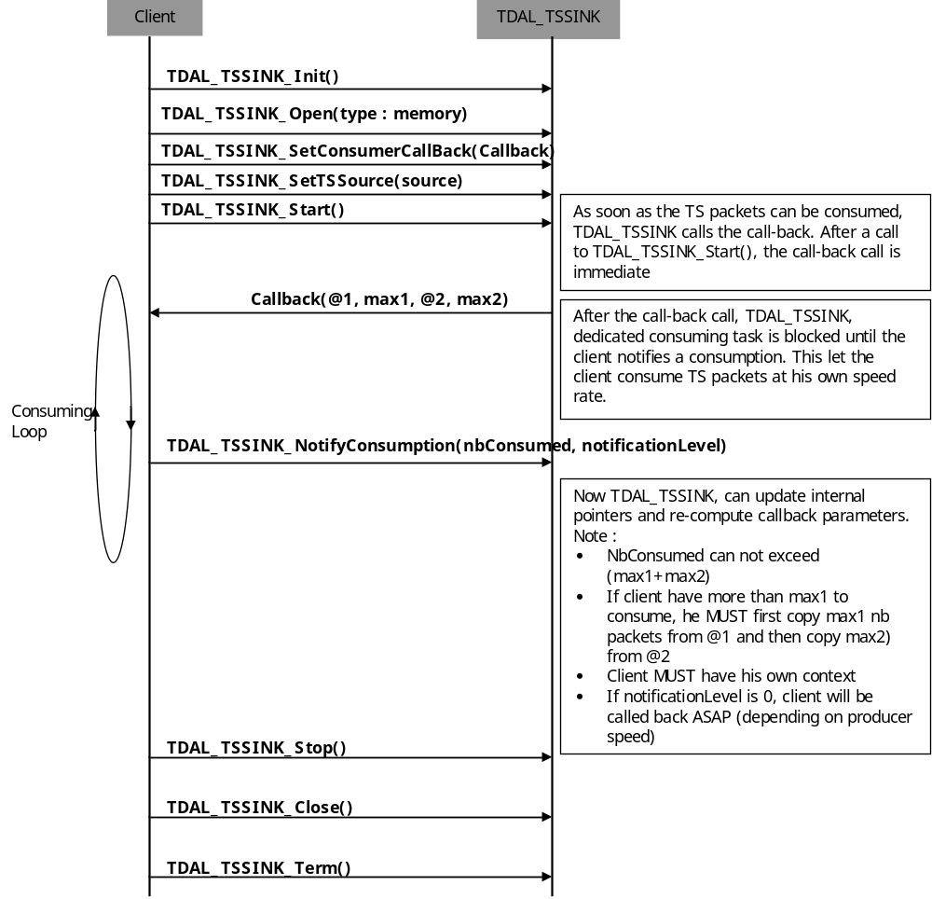

TS Source Jump request scenario
This schematic is an example of TDAL_TSSOURCE/TDAL_TSSINK usage in a case of jump request mode.
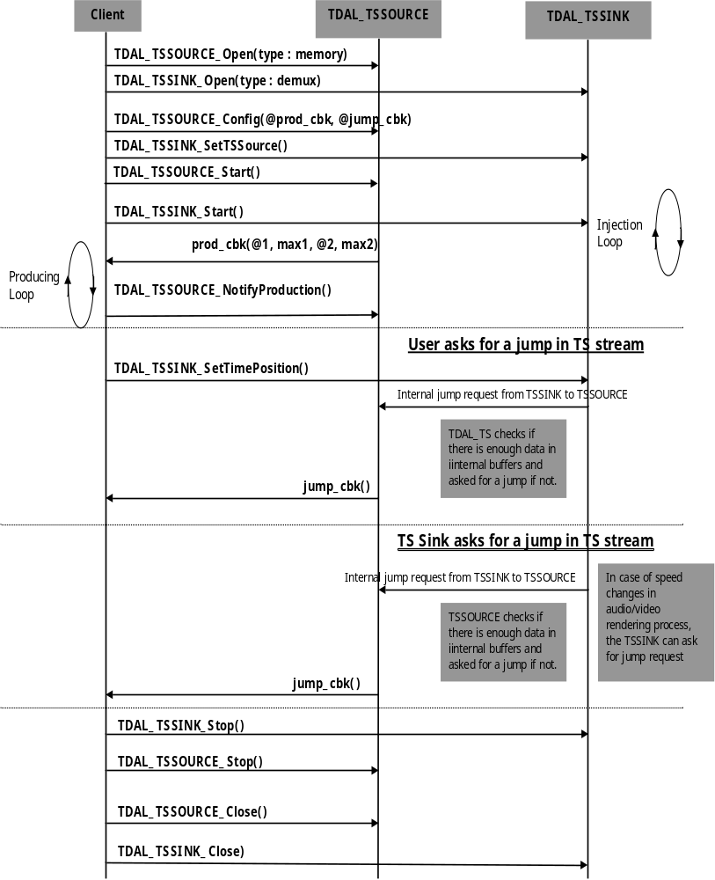

TDAL_TS Macro/Define/Enum/Typedef/Structure Definitions

Define Definitions

kTDAL_TS_MASK_CLASS
This constant is used to define the class mask of a TS object.
#define kTDAL_TS_MASK_CLASS 0xf000

kTDAL_TS_MASK_TYPE
This constant is used to define the type mask of a TS object.
#define kTDAL_TS_MASK_TYPE 0x0ff0

kTDAL_TS_MASK_INSTANCE
This constant is used to define the instance mask of a TS object.
#define kTDAL_TS_MASK_INSTANCE 0x000f

kTDAL_TS_NO_OBJECT
This constant is used to define the TS object invalid value.
#define kTDAL_TS_NO_OBJECT 0xffff

mTDAL_TS_GetObjectId
This macro is used to get the object from its class, type and instance.
#define mTDAL_TS_GetObjectId( class , type , instance ) \
(class << 12) + (type << 4) + instance

mTDAL_TS_GetObjectClass
This macro is used to get the class (source or destination) of a TDAL_TS object.
#define mTDAL_TS_GetObjectClass( object ) \
(object & kTDAL_TS_MASK_CLASS) >> 12

mTDAL_TS_GetObjectType
This macro is used to get the type (tuner, demux, memory, IEEE1394) of a TDAL_TS object.
#define mTDAL_TS_GetObjectType( object ) \
(object & kTDAL_TS_MASK_TYPE) >> 4

mTDAL_TS_GetObjectInstance
This macro is used to get the instance (0,…,n) of a TDAL_TS object
#define mTDAL_TS_GetObjectInstance( object ) \
(object & kTDAL_TS_MASK_INSTANCE)

Enum Definitions

Object class
An enumeration of the different object class.
enum {
eTDAL_TS_CLASS_SOURCE = 0 ,
eTDAL_TS_CLASS_DESTINATION
};

Object type
An enumeration of the different object type.
enum {
eTDAL_TS_TYPE_TUNER = 0,
eTDAL_TS_TYPE_IEEE1394 ,
eTDAL_TS_TYPE_MEMORY ,
eTDAL_TS_TYPE_DEMUX
};

tTDAL_TSROUTE_Error
An enumeration of the different possible errors generated by TDAL_TSROUTE module.
typedef enum
{
eTDAL_TSROUTE_NO_ERROR, /* No Error returned */
eTDAL_TSROUTE_ERROR_NOT_INIT, /* TDAL_TSROUTE has not been initialised */
eTDAL_TSROUTE_ERROR_BAD_ARG, /* Bad parameter given to the function */
eTDAL_TSROUTE_ERROR_IN_DRIVER, /* Low level driver returns an error */
eTDAL_TSROUTE_ERROR_CONFLICT, /* an object is already in used*/
eTDAL_TSROUTE_ERROR_NOT_DONE, /* Command not done*/
}tTDAL_TSROUTE_Error;

tTDAL_TSSOURCE_Error
An enumeration of the different possible errors generated by TDAL_TSSOURCE module.
typedef enum
{
eTDAL_TSSOURCE_NO_ERROR, /* No Error returned */
eTDAL_TSSOURCE_ERROR_BAD_ARG, /* Bad parameter given to the function */
eTDAL_TSSOURCE_ERROR_NO_MEMORY, /* Not enough memory */
eTDAL_TSSOURCE_ERROR_IN_DRIVER, /* Low level driver returns an error */
eTDAL_TSSOURCE_WARNING, /* an error occurred but operation
could be done */
eTDAL_TSSOURCE_ERROR_BAD_HANDLE, /* TS Source handle is wrong type */
eTDAL_TSSOURCE_ERROR_NOT_DONE, /* Command not done */
}tTDAL_TSSOURCE_Error;

tTDAL_TSSOURCE_Type
An enumeration of the different source type working mode.
typedef enum
{
eTDAL_TSSOURCE_TYPE_DEMUX, /* Data are produced by extraction from demux */
eTDAL_TSSOURCE_TYPE_MEMORY, /* Data are produced by an external module */
}tTDAL_TSSOURCE_Type;

tTDAL_TSSINK_Error
An enumeration of the different possible errors generated by TDAL_TSSINK module.
typedef enum
{
eTDAL_TSSINK_NO_ERROR, /* No Error returned */
eTDAL_TSSINK_ERROR_BAD_ARG, /* Bad parameter given to the function */
eTDAL_TSSINK_ERROR_NO_MEMORY, /* Not enough memory */
eTDAL_TSSINK_ERROR_IN_DRIVER, /* Low level driver returns an error */
eTDAL_TSSINK_ERROR_CONFLICT, /* error during access to a TS source
or a demux */
eTDAL_TSSINK_WARNING, /* an error occurred but operation
could be done */
eTDAL_TSSINK_ERROR_BAD_HANDLE, /* TS Source handle is wrong type */
eTDAL_TSSINK_ERROR_NOT_LINKED, /* (not used) */
eTDAL_TSSINK_ERROR_CAPABILITIES, /* Not handled in this TDAL_TSSINK
implementation */
eTDAL_TSSINK_ERROR_NOT_DONE, /* Command not done */
}tTDAL_TSSINK_Error;

tTDAL_TSSINK_Type
An enumeration of the different sink type working mode.
typedef enum
{
eTDAL_TSSINK_TYPE_DEMUX, /* Data are consumed by insertion in demux */
eTDAL_TSSINK_TYPE_MEMORY, /* Data are consumed by an external module */
}tTDAL_TSSINK_Type;

Typedef Definitions

tTDAL_TS_Object
This typedef defines a TS object.
typedef uint16_t tTDAL_TS_Object

tTDAL_TSSOURCE_Handle
This typedef defines a handle on TS source extraction .
typedef void *tTDAL_TSSOURCE_Handle

tTDAL_TSSOURCE_Pid
This typedef defines a PID for a TS source extraction.
typedef uint16_t tTDAL_TSSOURCE_Pid

tTDAL_TSSOURCE_ProducerCallbackFct
This typedef defined the callback function called to notify the external producer that data can be produced.
typedef void (* tTDAL_TSSOURCE_ProducerCallbackFct)
(
tTDAL_TSSOURCE_Handle handle,
uint8_t * address_1,
uint32_t nb_packets_max_1,
uint8_t * address_2,
uint32_t nb_packets_max_2,
void * private_data
);

tTDAL_TSSOURCE_RequestJumpCallbackFct
This typedef defines the callback function called to notify the external producer that a jump in source stream is needed.
typedef void (* tTDAL_TSSOURCE_RequestJumpCallbackFct)
(
tTDAL_TSSOURCE_Handle handle,
uint32_t packet_origin,
int32_t jump_ms,
uint32_t * p_new_packet_position,
void * private_data
);

tTDAL_TSSOURCE_TimestampingCallbackFct
This typedef defines the callback function called to notify client application of the TS time stamping.
typedef void (* tTDAL_TSSOURCE_TimestampingCallbackFct)
(
tTDAL_TSSOURCE_Handle handle,
void * client_tag,
uint32_t packet_position,
uint32_t packet_time_ms
);

tTDAL_TSSINK_Handle
This typedef defines a handle on TS sink injection.
typedef void *tTDAL_TSSOURCE_Handle

tTDAL_TSSINK_ConsumerCallbackFct
This typedef defines the callback function called when a buffer is full.
typedef void (* tTDAL_TSSINK_ConsumerCallbackFct)
(
tTDAL_TSSINK_Handle handle,
void * client_tag,
uint8_t * address_1,
uint32_t nb_packets_max_1,
uint8_t * address_2,
uint32_t nb_packets_max_2
);

Structure Definitions

tTDAL_TSROUTE_Capabilities
Description:
This structure defines the capabilities of a TDAL_TSROUTE implementation.
Definition:
typedef struct TDAL_TSROUTE_Capabilities_s
{
uint8_t nb_sources;
tTDAL_TS_Object *sources_array;
uint8_t nb_destinations;
tTDAL_TS_Object *destinations_array;
} tTDAL_TSROUTE_Capabilities;
Elements:
Field | Type | Description
nb_sources | uint8_t | Number of available source objects
sources_array | tTDAL_TS_Object * | Pointer to array of the available source objects. The number of element in the array is nb_sources value.
nb_destinations | uint8_t | Number of available destination objects
destinations_array | tTDAL_TS_Object * | Pointer to array of the available destination objects. The number of element in the array is nb_destinations value.
Comments:
None.
See Also:
tTDAL_TS_Object.
TDAL_TSROUTE_GetCapabilities(-).

tTDAL_TSROUTE_Status
Description:
This structure defines status information of TDAL_TS object.
Definition:
typedef struct TDAL_TSROUTE_Status_s
{
tTDAL_TS_Object connected_object;
uint32_t packet_count;
} tTDAL_TSROUTE_Status;
Elements:
Field | Type | Description
connected_object | tTDAL_TS_Object | TDAL_TS object instance currently connected.
packet_count | uint32_t | The total number of transport packets received. This is irrespective of PID matching. The delta between calls can be used to indicate whether there is an incoming stream.
Comments:
None.
See Also:
tTDAL_TS_Object.
TDAL_TSROUTE_GetStatus(-).

tTDAL_TSSOURCE_OpenParam
Description:
This structure defines structure containing parameters for opening a new TS extraction session.
Definition:
typedef struct TDAL_TSSOURCE_OpenParam_s
{
tTDAL_TSSOURCE_Type type;
uint32_t buffer_length;
uint32_t packet_length;
} tTDAL_TSSOURCE_OpenParam;
Elements:
Field | Type | Description
type | tTDAL_TSSOURCE_Type | Type of the TDAL_TSSOURCE session to open.
buffer_length | uint32_t | Size of internal memory buffer to allocate in number of packets.
packet_length | uint32_t | Size of transport packet in bytes.
Comments:
None.
See Also:
tTDAL_TSSOURCE_Type.
TDAL_TSSOURCE_Open(-).

tTDAL_TSSOURCE_ConfigParam
Description:
This structure defines configuration containing parameters for configuring a TS extraction session.
Definition:
typedef struct TDAL_TSSOURCE_ConfigParam_s
{
union {
struct {
tTDAL_TS_Object demux;
} dmx;
struct {
tTDAL_TSSOURCE_ProducerCallbackFct producer_callback;
tTDAL_TSSOURCE_RequestJumpCallbackFct request_jump_callback;
void * private_data;
} mem ;
} u ;
} tTDAL_TSSOURCE_ConfigParam;
Elements:
Field | Type | Description
u.dmx.demux | tTDAL_TS_Object | Demux object instance linked to the current TDAL_TSSOURCE session.
u.mem.producer_callback | tTDAL_TSSOURCE_ProducerCallbackFct | Pointer on a producer callback function
u.mem.request_jump_callback | tTDAL_TSSOURCE_RequestJumpCallbackFct | Pointer on a request jump callback function
u.mem.private_data | void * | Pointer to subscriber’s specific data. TDAL_TSSOURCE does nothing with this data except pass it to the callback functions
Comments:
None.
See Also:
tTDAL_TS_Object.
tTDAL_TSSOURCE_ProducerCallbackFct.
tTDAL_TSSOURCE_RequestJumpCallbackFct.
TDAL_TSSOURCE_Config(-).

tTDAL_TSSINK_OpenParam
Description:
This structure defines parameters for opening a new TS injection session.
Definition:
typedef struct TDAL_TSSINK_OpenParam_s
{
tTDAL_TSSINK_Type type;
tTDAL_TS_Object source;
tTDAL_TS_Object demux;
uint32_t notification_level;
} tTDAL_TSSINK_OpenParam;
Elements:
Field | Type | Description
type | tTDAL_TSSINK_Type | Type of the TDAL_TSSINK session to open.
source | tTDAL_TS_Object | Source object of the route that the TDAL_TSSINK session feeds.
demux | tTDAL_TS_Object | (Not used for the moment)
Notification_level | uint32_t | Number of packets level from which a notification of data ready to be consumed is done.  This value is only relevant if type is
Comments:
None.
See Also:
tTDAL_TSSINK_Type.
tTDAL_TS_Object.
TDAL_TSSINK_Open(-).

tTDAL_TSSINK_StartParam
Description:
This structure defines parameters for starting a TSSINK new injection.
Definition:
typedef struct TDAL_TSSINK_StartParam_s
{
bool tv_not_radio;
uint32_t initial_packet_number;
bool realtime;
} tTDAL_TSSINK_StartParam;
Elements:
Field | Type | Description
tv_not_radio | Bool | If TV program, true. If RADIO program, false.  This parameter can be used for a TSSINK demux session to manage the type of synchronization mode on video or audio stream.
initial_packet_number | uint32_t | Position of initial packet from which to start the injection.
realtime | bool | TRUE if injection is done from a live feed. FALSE otherwise.  This parameter can be used for a TSSINK demux session in conjunction with tv_not_radio parameter to manage who is the master of the synchronisation.
Comments:
None.
See Also:
TDAL_TSSINK_Start(-).

tTDAL_TSSINK_Status
Description:
This structure defines status information about an injection.
Definition:
typedef struct TDAL_TSSINK_Status_s
{
uint32_t byterate_Bps;
bool end_of_injection;
} tTDAL_TSSINK_Status;
Elements:
Field | Type | Description
byterate_Bps | uint32_t | TS global byte rate in Bytes/sec
end_of_injection | bool | This boolean indicates that the injection is finished : all TS data has been consumed.
Comments:
This status information is only used in case of a TDAL_TSSINK demux session.
The ‘end_of_injection’ boolean helps the TDAL_TSSINK client to determine the end of playback with accuracy.
See Also:
TDAL_TSSINK_GetStatus(-).

TDAL_TS API Functions

TS Generic Interface API

TDAL_TS_APIRevisionGet(-)
Prototype:
const char *TDAL_TS_APIRevisionGet(void);
Description:
This function retrieves the API revision.
Return value:
A string containing the revision of the TDAL_TS API.
Parameters:
None.
Comments:
This function can be called at any time.
See Also:

TDAL_TS_PlatformRevisionGet(-)
Prototype:
const char *TDAL_DSIP_PlatformRevisionGet(void);
Description:
This function retrieves the platform implementation revision.
Return value:
A string containing the revision of the TDAL_TS implementation on a platform.
Parameters:
None.
Comments:
This function can be called at any time.
See Also:

TS Route Interface API

TDAL_TSROUTE_Init(-)
Prototype:
tTDAL_TSROUTE_Error TDAL_TSROUTE_Init (void);
Description:
This function initialises the TDAL_TSROUTE module.
Return value:
It returns eTDAL_TSROUTE_NO_ERROR if initialization succeed.
It could eTDAL_TSROUTE_ERROR_NOT_DONE otherwise.
Parameters:
None.
Comments:
This function must be called before any other functions of the TDAL_TSROUTE API.
See Also:
TDAL_TSROUTE_Term(-).

TDAL_TSROUTE_Term(-)
Prototype:
tTDAL_TSROUTE_Error TDAL_TSROUTE_Term (void);
Description:
This function terminates the TDAL_TSROUTE module.
Return value:
It returns eTDAL_TSROUTE_NO_ERROR if termination succeed.
It could be eTDAL_TSROUTE_ERROR_NOT_DONE, eTDAL_TSROUTE_ERROR_NOT_INIT otherwise.
Parameters:
None.
Comments:
Any function of TDAL_TSROUTE API should not be called after TDAL_TSROUTE_Term(-) call.
See Also:
TDAL_TSROUTE_Init(-).

TDAL_TSROUTE_GetCapabilities(-)
Prototype:
tTDAL_TSROUTE_Error TDAL_TSROUTE_GetCapabilities
(
tTDAL_TSROUTE_Capabilities *p_capabilities
);
Description:
This function retrieves the capabilities of the TDAL_TSROUTE current implementation.
Return value:
It returns eTDAL_TSROUTE_NO_ERROR if retrieve of capabilities succeed. It could be eTDAL_TSROUTE_ERROR_NOT_INIT, eTDAL_TSROUTE_ERROR_IN_DRIVER, eTDAL_TSROUTE_ERROR_BAD_ARG otherwise.
Parameters:
Parameter | Type | Dir | Description
p_capabilities | tTDAL_TSROUTE_Capabilities * | In/out | In: Allocated capability structure pointer.  Out: Structure filled with capabilities of the implementation of the TDAL_TSROUTE module.
Comments:
This function can be called at any time the TDAL_TSROUTE has been initialised with TDAL_TSROUTE_Init(-) but not after the termination with TDAL_TSROUTE_Term(-).
See Also:
tTDAL_TSROUTE_Capabilities.

TDAL_TSROUTE_Connect(-)
Prototype:
tTDAL_TSROUTE_Error TDAL_TSROUTE_Connect
(
tTDAL_TS_Object source,
tTDAL_TS_Object destination
);
Description:
This function makes a route between two objects.
Return value:
It returns eTDAL_TSROUTE_NO_ERROR if connection succeed. It could be eTDAL_TSROUTE_ERROR_NOT_INIT, eTDAL_TSROUTE_ERROR_IN_DRIVER, eTDAL_TSROUTE_ERROR_NOT_DONE, eTDAL_TSROUTE_ERROR_BAD_ARG otherwise.
eTDAL_TSROUTE_ERROR_CONFLICT is returned if one object already connected.
Parameters:
Parameter | Type | Dir | Description
source | tTDAL_TS_Object | In | Source object to connect.
destination | tTDAL_TS_Object | In | Destination object to be connected.
Comments:
This function can be called at any time the TDAL_TSROUTE has been initialised with TDAL_TSROUTE_Init(-) but not after the termination with TDAL_TSROUTE_Term(-).
See Also:
tTDAL_TS_Object.
TDAL_TSROUTE_Disconnect(-).

TDAL_TSROUTE_Disconnect(-)
Prototype:
tTDAL_TSROUTE_Error TDAL_TSROUTE_Disconnect
(
tTDAL_TS_Object source,
tTDAL_TS_Object destination
);
Description:
This function removes a route between two objects
Return value:
It returns eTDAL_TSROUTE_NO_ERROR if retrieve of capabilities succeed. It could be eTDAL_TSROUTE_ERROR_NOT_INIT, eTDAL_TSROUTE_ERROR_IN_DRIVER, eTDAL_TSROUTE_ERROR_BAD_ARG otherwise.
eTDAL_TSROUTE_ERROR_NOT_DONE is returned if the connection to remove does not exist.
Parameters:
Parameter | Type | Dir | Description
source | tTDAL_TS_Object | In | Source object to disconnect.
destination | tTDAL_TS_Object | In | Destination object to be disconnected.
Comments:
This function can be called at any time the TDAL_TSROUTE has been initialised with TDAL_TSROUTE_Init(-) but not after the termination with TDAL_TSROUTE_Term(-).
See Also:
tTDAL_TS_Object.
TDAL_TSROUTE_Connect(-).

TDAL_TSROUTE_GetStatus(-)
Prototype:
tTDAL_TSROUTE_Error TDAL_TSROUTE_GetStatus
(
tTDAL_TS_Object object,
tTDAL_TSROUTE_Status *p_status
);
Description:
This function gets the connection status of an object.
Return value:
It returns eTDAL_TSROUTE_NO_ERROR if retrieve of capabilities succeed. It could be eTDAL_TSROUTE_ERROR_NOT_INIT, eTDAL_TSROUTE_ERROR_IN_DRIVER, eTDAL_TSROUTE_ERROR_BAD_ARG otherwise.
Parameters:
Parameter | Type | Dir | Description
object | tTDAL_TS_Object | In | TS Object.
p_status | tTDAL_TSROUTE_Status * | In/Out | In: Allocated pointer to a status structure.  Out: Pointer filled with information status of the object.
Comments:
This function can be called at any time the TDAL_TSROUTE has been initialised with TDAL_TSROUTE_Init(-) but not after the termination with TDAL_TSROUTE_Term(-).
See Also:
tTDAL_TS_Object.
tTDAL_TSROUTE_Status.

TS Source Interface API

TDAL_TSSOURCE_Init(-)
Prototype:
GLOBAL tTDAL_TSSOURCE_Error TDAL_TSSOURCE_Init (void);
Description:
This function initialises the TDAL_TSSOURCE module.
Return value:
It returns eTDAL_TSSOURCE_NO_ERROR succeed.
It could be eTDAL_TSSOURCE_ERROR_IN_DRIVER, eTDAL_TSSOURCE_ERROR_NOT_DONE otherwise.
Parameters:
None.
Comments:
This function must be called before any other functions of the TDAL_TSSOURCE API.
See Also:
TDAL_TSSOURCE_Term(-).

TDAL_TSSOURCE_Term(-)
Prototype:
GLOBAL tTDAL_TSSOURCE_Error TDAL_TSSOURCE_Term (void);
Description:
This function terminates the TDAL_TSSOURCE driver.
Return value:
It returns eTDAL_TSSOURCE_NO_ERROR succeed.
It could be eTDAL_TSROUTE_ERROR_NOT_INIT, eTDAL_TSROUTE_ERROR_IN_DRIVER, eTDAL_TSROUTE_ERROR_NOT_DONE otherwise.
Parameters:
None.
Comments:
This function can be called at any time the TDAL_TSSOURCE has been initialised with TDAL_TSSOURCE_Init(-).
See Also:
TDAL_TSSOURCE_Init(-).

TDAL_TSSOURCE_Open(-)
Prototype:
GLOBAL tTDAL_TSSOURCE_Error TDAL_TSSOURCE_Open
(
tTDAL_TSSOURCE_Handle *p_handle,
tTDAL_TSSOURCE_OpenParam *p_oprm
);
Description:
This function initializes a TS extraction session.
Return value:
It returns eTDAL_TSSOURCE_NO_ERROR if the open session succeed. It could be eTDAL_TSSOURCE_ERROR_IN_DRIVER, eTDAL_TSSOURCE_ERROR_BAD_ARG, eTDAL_TSSOURCE_ERROR_NOT_DONE otherwise.
eTDAL_TSSOURCE_ERROR_NO_MEMORY if there is not enough memory to allocate the TS extraction source session (internal data and buffers).
Parameters:
Parameter | Type | Dir | Description
p_handle | tTDAL_TSSOURCE_Handle * | In/Out | In: Allocated to a source handle pointer.  Out: Pointer filled with the handle on source TS extraction session.
p_oprm | tTDAL_TSSOURCE_OpenParam * | In | Pointer to open parameters of the source TS extraction session.
Comments:
This function can be called at any time the TDAL_TSSOURCE has been initialised with TDAL_TSSOURCE_Init(-) but not after the termination with TDAL_TSSOURCE_Term(-).
See Also:
tTDAL_TSSOURCE_Handle.
tTDAL_TSSOURCE_OpenParam.

TDAL_TSSOURCE_Config(-)
Prototype:
GLOBAL tTDAL_TSSOURCE_Error TDAL_TSSOURCE_Config
(
tTDAL_TSSOURCE_Handle handle,
tTDAL_TSSOURCE_ConfigParam *p_cfgprm
);
Description:
This function configures a TS extraction session.
Return value:
It returns eTDAL_TSSOURCE_NO_ERROR if configuration succeed. It could be eTDAL_TSSOURCE_ERROR_IN_DRIVER, eTDAL_TSROUTE_ERROR_BAD_ARG otherwise.
Parameters:
Parameter | Type | Dir | Description
handle | tTDAL_TSSOURCE_Handle | In | Previously opened TS extraction session handle
p_cfgprm | tTDAL_TSSOURCE_ConfigParam * | In | Pointer to configuration parameters to be applied.
Comments:
This function can be called at any time the TDAL_TSROUTE has been initialised with TDAL_TSROUTE_Init(-) but not after the termination with TDAL_TSROUTE_Term(-).
If an error occurs in this function, it restores the previous state before configuration.
See Also:
tTDAL_TSSOURCE_Handle.
tTDAL_TSSOURCE_ConfigParam.

TDAL_TSSOURCE_Close(-)
Prototype:
GLOBAL tTDAL_TSSOURCE_Error TDAL_TSSOURCE_Close
(
tTDAL_TSSOURCE_Handle handle
);
Description:
This function closes a TS extraction session.
Return value:
It returns eTDAL_TSSOURCE_NO_ERROR if close session succeed. It could be eTDAL_TSROUTE_ERROR_IN_DRIVER, eTDAL_TSROUTE_ERROR_BAD_ARG otherwise.
Parameters:
Parameter | Type | Dir | Description
handle | tTDAL_TSSOURCE_Handle | In | Previously opened TS extraction session handle
Comments:
This function can be called at any time the TDAL_TSSOURCE has been initialised with TDAL_TSSOURCE_Init(-) but not after the termination with TDAL_TSSOURCE_Term(-).
This source TS extraction session is stopped and all related resources are now available for another usage.
See Also:
tTDAL_TSSOURCE_Handle.

TDAL_TSSOURCE_AddPid(-)
Prototype:
GLOBAL tTDAL_TSSOURCE_Error TDAL_TSSOURCE_AddPid
(
tTDAL_TSSOURCE_Handle handle,
tTDAL_TSSOURCE_Pid pid
);
Description:
This function adds a PID to a TS extraction session.
Return value:
It returns eTDAL_TSSOURCE_NO_ERROR if succeed.
eTDAL_TSSOURCE_ERROR_BAD_HANDLE is returned if source TS extraction handle does not correspond to a demux type working mode session.
It could be eTDAL_TSSOURCE_ERROR_IN_DRIVER, eTDAL_TSSOURCE_ERROR_BAD_ARG, eTDAL_TSSOURCE_ERROR_NOT_DONE otherwise.
Parameters:
Parameter | Type | Dir | Description
handle | tTDAL_TSSOURCE_Handle | In | Previously opened TS extraction session handle
pid | tTDAL_TSSOURCE_Pid | In | PID to add in TS extraction.
Comments:
This function can be called at any time the TDAL_TSSOURCE has been initialised with TDAL_TSSOURCE_Init(-) but not after the termination with TDAL_TSSOURCE_Term(-).
A previous call to TDAL_TSSOURCE_Config(-) must have been made before calling this function.
If an error occurs in this function, it restores the previous state of the source TS extraction session.
See Also:
tTDAL_TSSOURCE_Handle.
tTDAL_TSSOURCE_Pid.
TDAL_TSSOURCE_RemovePid(-).

TDAL_TSSOURCE_RemovePid(-)
Prototype:
GLOBAL tTDAL_TSSOURCE_Error TDAL_TSSOURCE_RemovePid
(
tTDAL_TSSOURCE_Handle handle,
tTDAL_TSSOURCE_Pid pid
);
Description:
This function removes a PID from a TS extraction session.
Return value:
It returns eTDAL_TSSOURCE_NO_ERROR if succeed.
eTDAL_TSSOURCE_ERROR_BAD_HANDLE is returned if source TS extraction handle does not correspond to a demux type working mode session.
It could be eTDAL_TSROUTE_ERROR_NOT_INIT, eTDAL_TSROUTE_ERROR_IN_DRIVER, eTDAL_TSROUTE_ERROR_BAD_ARG, eTDAL_TSSOURCE_ERROR_NOT_DONE otherwise.
Parameters:
Parameter | Type | Dir | Description
handle | tTDAL_TSSOURCE_Handle | In | Previously opened TS extraction session handle
pid | tTDAL_TSSOURCE_Pid | In | PID to remove from TS extraction.
Comments:
This function can be called at any time the TDAL_TSSOURCE has been initialised with TDAL_TSSOURCE_Init(-) but not after the termination with TDAL_TSSOURCE_Term(-).
If an error occurs in this function, it restores the previous state of the source TS extraction session.
See Also:
tTDAL_TSSOURCE_Handle.
tTDAL_TSSOURCE_Pid.
TDAL_TSSOURCE_AddPid(-).

TDAL_TSSOURCE_Start(-)
Prototype:
GLOBAL tTDAL_TSSOURCE_Error TDAL_TSSOURCE_Start
(
tTDAL_TSSOURCE_Handle handle
);
Description:
This function starts TS source session.
Return value:
It returns eTDAL_TSSOURCE_NO_ERROR succeed.
It could be eTDAL_TSSOURCE_ERROR_IN_DRIVER, eTDAL_TSSOURCE_ERROR_BAD_ARG, eTDAL_TSSOURCE_ERROR_NOT_DONE otherwise.
Parameters:
Parameter | Type | Dir | Description
handle | tTDAL_TSSOURCE_Handle | In | Previously opened TS extraction session handle
Comments:
This function can be called at any time the TDAL_TSSOURCE has been initialised with TDAL_TSSOURCE_Init(-) but not after the termination with TDAL_TSSOURCE_Term(-).
This function spawns an extracting thread to produce TS data.
See Also:
tTDAL_TSSOURCE_Handle.
TDAL_TSSOURCE_Stop(-).

TDAL_TSSOURCE_Stop(-)
Prototype:
GLOBAL tTDAL_TSSOURCE_Error TDAL_TSSOURCE_Stop
(
tTDAL_TSSOURCE_Handle handle
);
Description:
This function stops TS source session.
Return value:
It returns eTDAL_TSSOURCE_NO_ERROR succeed.
It could be eTDAL_TSSOURCE_ERROR_IN_DRIVER, eTDAL_TSSOURCE_ERROR_BAD_ARG, eTDAL_TSSOURCE_ERROR_NOT_DONE otherwise.
Parameters:
Parameter | Type | Dir | Description
handle | tTDAL_TSSOURCE_Handle | In | Previously opened TS extraction session handle
Comments:
This function can be called at any time the TDAL_TSSOURCE has been initialised with TDAL_TSSOURCE_Init(-) but not after the termination with TDAL_TSSOURCE_Term(-).
It stops the extracting thread producing TS data.
See Also:
tTDAL_TSSOURCE_Handle.
TDAL_TSSOURCE_Start(-).

TDAL_TSSOURCE_SetTimestampingCallback(-)
Prototype:
GLOBAL tTDAL_TSSOURCE_Error TDAL_TSSOURCE_SetTimestampingCallback
(
tTDAL_TSSOURCE_Handle handle,
tTDAL_TSSOURCE_TimestampingCallbackFct timestamping_callback,
void * client_tag
);
Description:
This function sets the time stamping consumer callback.
Return value:
It returns eTDAL_TSSOURCE_NO_ERROR succeed.
It could be eTDAL_TSSOURCE_ERROR_BAD_ARG, eTDAL_TSSOURCE_ERROR_NOT_DONE otherwise.
eTDAL_TSSOURCE_ERROR_BAD_HANDLE is returned if source TS extraction handle does not correspond to a demux type working mode session.
Parameters:
Parameter | Type | Dir | Description
handle | tTDAL_TSSOURCE_Handle | In | Previously opened TS extraction session handle
timestamping_callback | tTDAL_TSOURCE_TimeStampingCallbackFct | In | Pointer on a time stamping callback function
client_tag | void * | In | Pointer to client’s specific data. TDAL_TSOURCE does nothing with this data except pass it to the callback function.
Comments:
This function can be called at any time the TDAL_TSSOURCE has been initialised with TDAL_TSSOURCE_Init(-) but not after the termination with TDAL_TSSOURCE_Term(-).

See Also:
tTDAL_TSSOURCE_Handle.
tTDAL_TSSOURCE_TimestampingCallbackFct.

TDAL_TSSOURCE_NotifyProduction(-)
Prototype:
GLOBAL tTDAL_TSSOURCE_Error TDAL_TSSOURCE_NotifyProduction
(
tTDAL_TSSOURCE_Handle handle,
uint32_t produced_packets,
uint32_t notification_level
);
Description:
This function notifies client that a buffer is processed and could be re-used.
Return value:
It returns eTDAL_TSSOURCE_NO_ERROR succeed.
It could be eTDAL_TSSOURCE_ERROR_BAD_ARG, eTDAL_TSSOURCE_ERROR_NOT_DONE otherwise.
eTDAL_TSSOURCE_ERROR_BAD_HANDLE is returned if source TS extraction handle does not correspond to a memory type working mode session.
Parameters:
Parameter | Type | Dir | Description
handle | tTDAL_TSSOURCE_Handle | In | Previously opened TS extraction session handle
uint32_t | produced_packets | In | Number of packets that the client has produced.
uint32_t | notification_level | In | Minimum number of packets in free area to be able to produce before notifying the external producer.
Comments:
This function can be called at any time the TDAL_TSSOURCE has been initialised with TDAL_TSSOURCE_Init(-) but not after the termination with TDAL_TSSOURCE_Term(-).
See Also:
tTDAL_TSSOURCE_Handle.
tTDAL_TSSOURCE_ProducerCallbackFct.

TDAL_TSSOURCE_Pause(-)
Prototype:
GLOBAL tTDAL_TSSOURCE_Error TDAL_TSSOURCE_Pause
(
tTDAL_TSSOURCE_Handle handle,
bool reinit_pointer
);
Description:
This function pauses a TS memory source session.
Return value:
It returns eTDAL_TSSOURCE_NO_ERROR succeed.
It could be eTDAL_TSSOURCE_ERROR_BAD_ARG, eTDAL_TSSOURCE_ERROR_NOT_DONE otherwise.
eTDAL_TSSOURCE_ERROR_BAD_HANDLE is returned if source TS extraction handle does not correspond to a memory type working mode session.
Parameters:
Parameter | Type | Dir | Description
handle | tTDAL_TSSOURCE_Handle | In | Previously opened TS extraction session handle
reinit_pointer | bool | In | TRUE to indicate to reinitialize the internal producing pointer of the source session. FALSE to not change the internal pointer.
Comments:
This function can be called at any time the TDAL_TSSOURCE has been initialised with TDAL_TSSOURCE_Init(-) but not after the termination with TDAL_TSSOURCE_Term(-).
See Also:
tTDAL_TSSOURCE_Handle.
TDAL_TSSOURCE_Resume(-).

TDAL_TSSOURCE_Resume(-)
Prototype:
GLOBAL tTDAL_TSSOURCE_Error TDAL_TSSOURCE_Resume
(
tTDAL_TSSOURCE_Handle handle
);
Description:
This function resumes a paused TS memory source session.

Return value:
It returns eTDAL_TSSOURCE_NO_ERROR succeed.
It could be eTDAL_TSSOURCE_ERROR_BAD_ARG, eTDAL_TSSOURCE_ERROR_NOT_DONE otherwise.
eTDAL_TSSOURCE_ERROR_BAD_HANDLE is returned if source TS extraction handle does not correspond to a memory type working mode session.
Parameters:
Parameter | Type | Dir | Description
handle | tTDAL_TSSOURCE_Handle | In | Previously opened TS extraction session handle
Comments:
This function can be called at any time the TDAL_TSSOURCE has been initialised with TDAL_TSSOURCE_Init(-) but not after the termination with TDAL_TSSOURCE_Term(-).
See Also:
tTDAL_TSSOURCE_Handle.
TDAL_TSSOURCE_Pause(-).

TS Sink Interface API

TDAL_TSSINK_Init(-)
Prototype:
GLOBAL tTDAL_TSSINK_Error TDAL_TSSINK_Init (void);
Description:
This function initialises the TDAL_TSSINK module.
Return value:
It returns eTDAL_TSSINK_NO_ERROR succeed.
It could be eTDAL_TSSINK_ERROR_IN_DRIVER, eTDAL_TSSINK_ERROR_NOT_DONE otherwise.
Parameters:
None.
Comments:
This function must be called before any other functions of the TDAL_TSSINK API.
See Also:
TDAL_TSSINK_Term(-).

TDAL_TSSINK_Term(-)
Prototype:
GLOBAL tTDAL_TSSINK_Error TDAL_TSSINK_Term (void);
Description:
This function terminates the TDAL_TSSINK driver.
Return value:
It returns eTDAL_TSSINK_NO_ERROR succeed.
It could be eTDAL_TSSINK_ERROR_IN_DRIVER, eTDAL_TSSINK_ERROR_NOT_DONE otherwise.
Parameters:
None.
Comments:
This function can be called at any time the TDAL_TSSINK has been initialised with TDAL_TSSINK_Init(-).
See Also:
TDAL_TSSINK_Init(-).

TDAL_TSSINK_Open(-)
Prototype:
GLOBAL tTDAL_TSSINK_Error TDAL_TSSINK_Open
(
tTDAL_TSSINK_Handle *p_handle,
tTDAL_TSSINK_OpenParam *p_oprm
);
Description:
This function initializes a TS insertion session.
Return value:
It returns eTDAL_TSSINK_NO_ERROR if the open session succeed. It could be eTDAL_TSSINK_ERROR_IN_DRIVER, eTDAL_TSSINK_ERROR_BAD_ARG, eTDAL_TSSINK_ERROR_NOT_DONE otherwise.
eTDAL_TSSINK_ERROR_NO_MEMORY if there is not enough memory to allocate the sink TS insertion session (internal data and buffers).
Parameters:
Parameter | Type | Dir | Description
p_handle | tTDAL_TSSINK_Handle * | In/Out | In: Allocated to a sink handle pointer.  Out: Pointer filled with the handle on sink TS insertion session.
p_oprm | tTDAL_TSSINK_OpenParam * | In | Pointer to open parameters of the sink TS insertion session.
Comments:
This function can be called at any time the TDAL_TSSINK has been initialised with TDAL_TSSINK_Init(-) but not after the termination with TDAL_TSSINK_Term(-).
See Also:
tTDAL_TSSINK_Handle.
tTDAL_TSSINK_OpenParam.
TDAL_TSSINK_Close(-).

TDAL_TSSINK_Close(-)
Prototype:
GLOBAL tTDAL_TSSINK_Error TDAL_TSSINK_Close
(
tTDAL_TSSINK_Handle handle
);
Description:
This function closes a TS insertion session.
Return value:
It returns eTDAL_TSSINK_NO_ERROR if close session succeed. It could be eTDAL_TSSINK_ERROR_IN_DRIVER, eTDAL_TSSINK_ERROR_BAD_ARG otherwise.
Parameters:
Parameter | Type | Dir | Description
Handle | tTDAL_TSSINK_Handle | In | Previously opened TS extraction session handle
Comments:
This function can be called at any time the TDAL_TSSINK has been initialised with TDAL_TSSINK_Init(-) but not after the termination with TDAL_TSSINK_Term(-).
This sink TS insertion session is stopped and all related resources are now available for another usage.
See Also:
tTDAL_TSSINK_Handle.
TDAL_TSSINK_Open(-).

TDAL_TSSINK_Start(-)
Prototype:
GLOBAL tTDAL_TSSINK_Error TDAL_TSSINK_Start
(
tTDAL_TSSINK_Handle handle,
tTDAL_TSSINK_StartParam *p_sprm
);
Description:
This function starts a TS insertion session.
Return value:
It returns eTDAL_TSSINK_NO_ERROR if succeed.
It could be eTDAL_TSSINK_ERROR_IN_DRIVER, eTDAL_TSSINK_ERROR_BAD_ARG,
eTDAL_TSSINK_ERROR_NOT_DONE,
eTDAL_TSSINK_ERROR_BAD_HANDLE otherwise.
Parameters:
Parameter | Type | Dir | Description
handle | tTDAL_TSSINK_Handle | In | Previously opened TS extraction session handle
p_sprm | tTDAL_TSSINK_StartParam * | In | Pointer to start parameters to be applied.
Comments:
This function can be called at any time the TDAL_TSSINK has been initialised with TDAL_TSSINK_Init(-) but not after the termination with TDAL_TSSINK_Term(-).
This sink TS insertion session is started only if a previous call to TDAL_TSSINK_SetTSSource(-) has been made.
See Also:
tTDAL_TSSINK_Handle.
tTDAL_TSSINK_StartParam.
TDAL_TSSINK_StartFrom(-).
TDAL_TSSINK_Stop(-).

TDAL_TSSINK_StartFrom(-)
Prototype:
GLOBAL tTDAL_TSSINK_Error TDAL_TSSINK_StartFrom
(
tTDAL_TSSINK_Handle handle,
tTDAL_TSSINK_Handle predecessor,
tTDAL_TSSINK_StartParam *p_sprm
);
Description:
This function starts injecting data at same position of 'predecessor' sink TS insertion session.
Return value:
It returns eTDAL_TSSINK_NO_ERROR if succeed.
It could be eTDAL_TSSINK_ERROR_IN_DRIVER, eTDAL_TSSINK_ERROR_BAD_ARG,
eTDAL_TSSINK_ERROR_NOT_DONE,
eTDAL_TSSINK_ERROR_BAD_HANDLE otherwise.
Parameters:
Parameter | Type | Dir | Description
handle | tTDAL_TSSINK_Handle | In | Previously opened TS extraction session handle
predecessor | tTDAL_TSSINK_Handle | In | Previously opened predecessor TS extraction session handle
p_sprm | tTDAL_TSSINK_StartParam * | In | Pointer to start parameters to be applied.
Comments:
This function can be called at any time the TDAL_TSSINK has been initialised with TDAL_TSSINK_Init(-) but not after the termination with TDAL_TSSINK_Term(-).
This sink TS insertion session is started only if a previous call to TDAL_TSSINK_SetTSSource(-) has been made.
If predecessor is not NULL (meaning not invalid value), the consuming internal position of the corresponding sink TS insertion session is used as new position of the sink TS insertion session to start.
The ‘predecessor’ is typically used in a timeshift scenario in order to start with a correct TS data continuity a sink TS memory session from a sink TS demux session.
See Also:
tTDAL_TSSINK_Handle.
tTDAL_TSSINK_StartParam.
TDAL_TSSINK_Start(-).
TDAL_TSSINK_Stop(-).

TDAL_TSSINK_Stop(-)
Prototype:
GLOBAL tTDAL_TSSINK_Error TDAL_TSSINK_Stop
(
tTDAL_TSSINK_Handle handle
);
Description:
This function stops the injection of data of a TS insertion session.
Return value:
It returns eTDAL_TSSINK_NO_ERROR if succeed.
It could be eTDAL_TSSINK_ERROR_IN_DRIVER, eTDAL_TSSINK_ERROR_BAD_ARG,
eTDAL_TSSINK_ERROR_NOT_DONE,
eTDAL_TSSINK_ERROR_BAD_HANDLE otherwise.
Parameters:
Parameter | Type | Dir | Description
Handle | tTDAL_TSSINK_Handle | In | Previously opened TS extraction session handle
Comments:
This function can be called at any time the TDAL_TSSINK has been initialised with TDAL_TSSINK_Init(-) but not after the termination with TDAL_TSSINK_Term(-).
This sink TS insertion session is stopped.
See Also:
tTDAL_TSSINK_Handle.
TDAL_TSSINK_Start(-).
TDAL_TSSINK_StartFrom(-).

TDAL_TSSINK_SetTimePosition(-)
Prototype:
GLOBAL tTDAL_TSSINK_Error TDAL_TSSINK_SetTimePosition
(
tTDAL_TSSINK_Handle handle,
bool relative,
signed int timeInMs
);
Description:
This function sets time position of a TS insertion session.
Return value:
It returns eTDAL_TSSINK_NO_ERROR if succeed.
eTDAL_TSSINK_ERROR_BAD_HANDLE is returned if sink TS insertion handle does not correspond to a demux type working mode session.
It could be eTDAL_TSSINK_ERROR_IN_DRIVER, eTDAL_TSSINK_ERROR_BAD_ARG otherwise.
Parameters:
Parameter | Type | Dir | Description
handle | tTDAL_TSSINK_Handle | In | Previously opened TS extraction session handle
relative | bool | In | TRUE if asked position if relative from current position.  FALSE otherwise.
timeInMs | signed int | In | time of new position to set (in millisecond).
Comments:
This function can be called at any time the TDAL_TSSINK has been initialised with TDAL_TSSINK_Init(-) but not after the termination with TDAL_TSSINK_Term(-).
See Also:
tTDAL_TSSINK_Handle.

TDAL_TSSINK_GetPacketPosition(-)
Prototype:
GLOBAL tTDAL_TSSINK_Error TDAL_TSSINK_GetPacketPosition
(
tTDAL_TSSINK_Handle handle,
uint32_t *p_packet_position
);
Description:
This function gets the real consumed packet position of a TS insertion session.
Return value:
It returns eTDAL_TSSINK_NO_ERROR if succeed.
eTDAL_TSSINK_ERROR_BAD_HANDLE is returned if sink TS insertion handle does not correspond to a demux type working mode session.
It could be eTDAL_TSSINK_ERROR_IN_DRIVER, eTDAL_TSSINK_ERROR_BAD_ARG otherwise.
Parameters:
Parameter | Type | Dir | Description
handle | tTDAL_TSSINK_Handle | In | Previously opened TS extraction session handle
p_packet_position | uint32_t * | In/Out | In: Allocated pointer to packet position.  Out: Current packet position in number of packets.
Comments:
This function can be called at any time the TDAL_TSSINK has been initialised with TDAL_TSSINK_Init(-) but not after the termination with TDAL_TSSINK_Term(-).
See Also:
tTDAL_TSSINK_Handle.

TDAL_TSSINK_GetStatus(-)
Prototype:
GLOBAL tTDAL_TSSINK_Error TDAL_TSSINK_GetStatus
(
tTDAL_TSSINK_Handle handle,
tTDAL_TSSINK_Status *p_status
);
Description:
This function gets status information about a TS insertion session.
Return value:
It returns eTDAL_TSSINK_NO_ERROR if succeed.
eTDAL_TSSINK_ERROR_BAD_HANDLE is returned if sink TS insertion handle does not correspond to a demux type working mode session.
It could be eTDAL_TSSINK_ERROR_IN_DRIVER, eTDAL_TSSINK_ERROR_BAD_ARG otherwise.
Parameters:
Parameter | Type | Dir | Description
handle | tTDAL_TSSINK_Handle | In | Previously opened TS extraction session handle
p_status | tTDAL_TSSINK_Status * | In/Out | In: Allocated pointer to status information.  Out: Pointer filled with the current status information.
Comments:
This function can be called at any time the TDAL_TSSINK has been initialised with TDAL_TSSINK_Init(-) but not after the termination with TDAL_TSSINK_Term(-).
See Also:
tTDAL_TSSINK_Handle.

TDAL_TSSINK_SetConsumerCallback(-)
Prototype:
GLOBAL tTDAL_TSSINK_Error TDAL_TSSINK_SetConsumerCallback
(
tTDAL_TSSINK_Handle handle,
tTDAL_TSSINK_ConsumerCallbackFct consumer_callback,
void *client_tag
);
Set the external consumer call-back
Description:
This function sets the external consumer callback of a TS insertion session.
Return value:
It returns eTDAL_TSSINK_NO_ERROR if succeed.
eTDAL_TSSINK_ERROR_BAD_HANDLE is returned if sink TS insertion handle does not correspond to a memory type working mode session.
It could be eTDAL_TSSINK_ERROR_IN_DRIVER, eTDAL_TSSINK_ERROR_BAD_ARG otherwise.
Parameters:
Parameter | Type | Dir | Description
handle | tTDAL_TSSINK_Handle | In | Previously opened TS extraction session handle
consumer_callback | tTDAL_TSSINK_ConsumerCallbackFct | In | Pointer on a consumer callback function
client_tag | void * | In | Pointer to client’s specific data. TDAL_TSSOURCE does nothing with this data except pass it to the callback functions
Comments:
This function can be called at any time the TDAL_TSSINK has been initialised with TDAL_TSSINK_Init(-) but not after the termination with TDAL_TSSINK_Term(-).
See Also:
tTDAL_TSSINK_Handle.
tTDAL_TSSINK_ConsumerCallbackFct.

TDAL_TSSINK_NotifyConsumption(-)
Prototype:
GLOBAL tTDAL_TSSINK_Error TDAL_TSSINK_NotifyConsumption
(
tTDAL_TSSINK_Handle handle,
uint32_t consumed_packets,
uint32_t notification_level
);
Description:
This function notifies client that a buffer is processed and could be re-used.
Return value:
It returns eTDAL_TSSINK_NO_ERROR if succeed.
eTDAL_TSSINK_ERROR_BAD_HANDLE is returned if sink TS insertion handle does not correspond to a memory type working mode session.
It could be eTDAL_TSSINK_ERROR_IN_DRIVER, eTDAL_TSSINK_ERROR_BAD_ARG otherwise.
Parameters:
Parameter | Type | Dir | Description
Handle | tTDAL_TSSINK_Handle | In | Previously opened TS extraction session handle
consumed_packets | uint32_t | In | Number of packets that the client has consumed
Notification_level | uint32_t | In | Minimum number of packets in valid data area to be able to consume before notifying the external consumer.
Comments:
This function can be called at any time the TDAL_TSSINK has been initialised with TDAL_TSSINK_Init(-) but not after the termination with TDAL_TSSINK_Term(-).
See Also:
tTDAL_TSSINK_Handle.
tTDAL_TSSINK_ConsumerCallbackFct.

TDAL_TSSINK_SetTSSource(-)
Prototype:
GLOBAL tTDAL_TSSINK_Error TDAL_TSSINK_SetTSSource
(
TTDAL_TSSINK_Handle handle,
tTDAL_TSSOURCE_Handle tssource_handle
);
Link this sink to a producer
Description:
This function links this sink TS insertion session to a source TS extraction session.
Return value:
It returns eTDAL_TSSINK_NO_ERROR if succeed.
It could be eTDAL_TSSINK_ERROR_IN_DRIVER, eTDAL_TSSINK_ERROR_BAD_ARG otherwise.
Parameters:
Parameter | Type | Dir | Description
Handle | tTDAL_TSSINK_Handle | In | Previously opened TS extraction session handle
Comments:
This function can be called at any time the TDAL_TSSINK has been initialised with TDAL_TSSINK_Init(-) but not after the termination with TDAL_TSSINK_Term(-).
Internally, this function allows the sink TS insertion session to access TS buffer of the source TS extraction session.
See Also:
tTDAL_TSSINK_Handle.
tTDAL_TSSOURCE_Handle.

TDAL_TS External DependEncies

tTDAL_TSSOURCE_ProducerCallbackFct
This typedef defined the callback function called to notify the external producer that data can be produced.
Prototype:
typedef void (* tTDAL_TSSOURCE_ProducerCallbackFct )
(
tTDAL_TSSOURCE_Handle handle,
uint8_t * address_1,
uint32_t nb_packets_max_1,
uint8_t * address_2,
uint32_t nb_packets_max_2,
void * private_data
);
Return value:
None.
Parameters:
Parameter | Type | Dir | Description
handle | tTDAL_TSSOURCE_Handle | In | handle on which “data can be produced” event occurs
address_1 | uint8_t * | In | 1st address where data can be copied
nb_packets_max_1 | uint32_t | In | Maximum number of TS packets that can copied in address_1
address_2 | uint8_t * | In | 2nd address where data can be copied
nb_packets_max_2 | uint32_t | In | Maximum number of TS packets that can copied in address_2
private_data | void * | In | Pointer to data private specific to the client subscriber, propagated from the subscription parameters passed to tTDAL_TSSOURCE_ConfigParam.
Comments:
As soon as the TS packets can be produced, TDAL_TSSOURCE calls this callback. After a call to TDAL_TSSOURCE_Start(-), the callback call is immediate.
After the callback call, TDAL_TSSOURCE dedicated producing task is blocked until the client notifies a production with the call of TDAL_TSSOURCE_NotifyProduction(-). This lets the client produce TS packets at its own speed rate.
The client can produce number of packets that must not exceed (nb_packets_max_1 + nb_packets_max_2).
If client have more than nb_packets_max_1 to produce, he MUST first copy nb_packets_max_1 number of packets at address_1 and then copy (nb_packets_produced – nb_packets_max_1) at address2 if not null.
See Also:
tTDAL_TSSOURCE_Handle.
tTDAL_TSSOURCE_ConfigParam.

tTDAL_TSSOURCE_RequestJumpCallbackFct
This typedef defines the callback function called to notify the external producer that a jump in source stream is needed.
Prototype:
typedef void (* tTDAL_TSSOURCE_RequestJumpCallbackFct )
(
tTDAL_TSSOURCE_Handle handle,
uint32_t packet_origin,
int32_t jump_ms,
uint32_t * p_new_packet_position,
void * private_data
);
Return value:
None.
Parameters:
Parameter | Type | Dir | Description
handle | tTDAL_TSSOURCE_Handle | In | handle on which a jump request event occurs
packet_origin | uint32_t | In | Current packet position from which a jump is requested.
jump_ms | int32_t | In | Number of milliseconds to jump forward if positive or backward if negative.
p_new_packet_position | uint32_t * | In/Out | In: Allocated pointer.  Out: pointer filled with the new packet position after the seek operation has been performed.
private_data | void * | In | Pointer to data private specific to the client subscriber, propagated from the subscription parameters passed to tTDAL_TSSOURCE_ConfigParam.
Comments:
None.
See Also:
tTDAL_TSSOURCE_Handle.
tTDAL_TSSOURCE_ConfigParam.

tTDAL_TSSOURCE_TimestampingCallbackFct
This typedef defines the callback function called to notify client application of the TS time stamping.
Prototype:
typedef void (* tTDAL_TSSOURCE_TimestampingCallbackFct )
(
tTDAL_TSSOURCE_Handle handle,
void * client_tag,
uint32_t packet_position,
uint32_t packet_time_ms
);
Return value:
None.
Parameters:
Parameter | Type | Dir | Description
handle | tTDAL_TSSOURCE_Handle | In | handle on which a time stamping event occurs
client_tag | void * | In | Pointer to data private specific to the client subscriber, propagated from the subscription parameters passed to TDAL_TSSOURCE_SetTimestampingCallback(-)
packet_position | uint32_t | In | Current packet position to timestamp
packet_time_ms | uint32_t | In | Current time in millisecond to timestamp.
Comments:
The main constraint of notifying time stamping information is that the delta between calls must follow a constant value of packet_position information.
A nominal value is to have a notification every 256 packets. The range is between 128 and 1024 packets.
See Also:
tTDAL_TSSOURCE_Handle.
TDAL_TSSOURCE_SetTimestampingCallback(-).

tTDAL_TSSINK_ConsumerCallbackFct
This typedef defines the callback function called when a buffer is full.
Prototype:
typedef void (* tTDAL_TSSINK_ConsumerCallbackFct )
(
tTDAL_TSSINK_Handle handle,
void * client_tag,
uint8_t * address_1,
uint32_t nb_packets_max_1,
uint8_t * address_2,
uint32_t nb_packets_max_2
);
Return value:
None.
Parameters:
Parameter | Type | Dir | Description
handle | tTDAL_TSSiNK_Handle | In | handle on which a buffer full event occurs
client_tag | void * | In | Pointer to data private specific to the client subscriber, propagated from the subscription parameters passed to TDAL_TSSINK_SetConsumerCallback(-)
address_1 | uint8_t * | In | 1st address where data can be retrieved
nb_packets_max_1 | uint32_t | In | Maximum number of TS packets that can be retrieved in address_1
address_2 | uint8_t * | In | 2nd address where data can be retrieved
nb_packets_max_2 | uint32_t | In | Maximum number of TS packets that can be retrieved in address_2
Comments:
As soon as the TS packets can be consumed, TDAL_TSSINK calls the call-back.
After the callback call, TDAL_TSSINK dedicated consuming task is blocked until the client notifies a consumption with the call of TDAL_TSSINK_NotifyConsumption(-). This lets the client consume TS packets at his own speed rate.
The client can consume number of packets that must not exceed (nb_packets_max_1 + nb_packets_max_2).
If client have more than nb_packets_max_1 to consume, he MUST first retrieve nb_packets_max_1 number of packets at address_1 and then retrieve nb_packets_max_2 at address2 if not null.

See Also:
tTDAL_TSSINK_Handle.
TDAL_TSSINK_SetConsumerCallback(-).

